**Supplementary materials on the ecological niche models of Juglandaceae species.**

Provided below are the predicted distribution maps of each Juglandaceae species across different time periods.

***Juglans* genus**

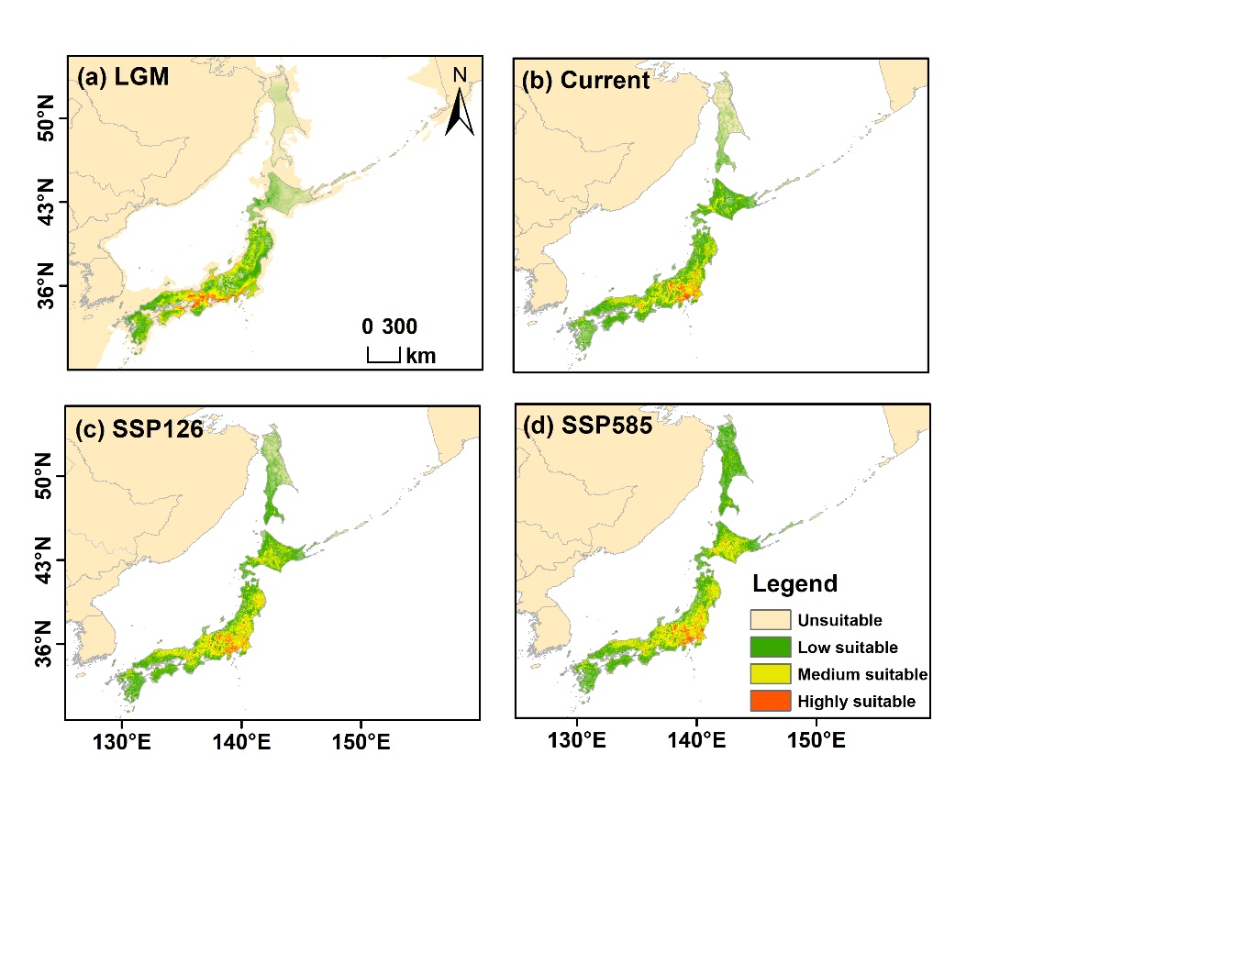

**Fig. A1** Predicted distribution ranges of *J. ailantifolia* from past to future. The color gradient from green to red represents low to high suitability. (a) represent LGM, Last Glacial Maximum, (b) current period, (c) SSP126 (2090), and SSP5858 (2090).

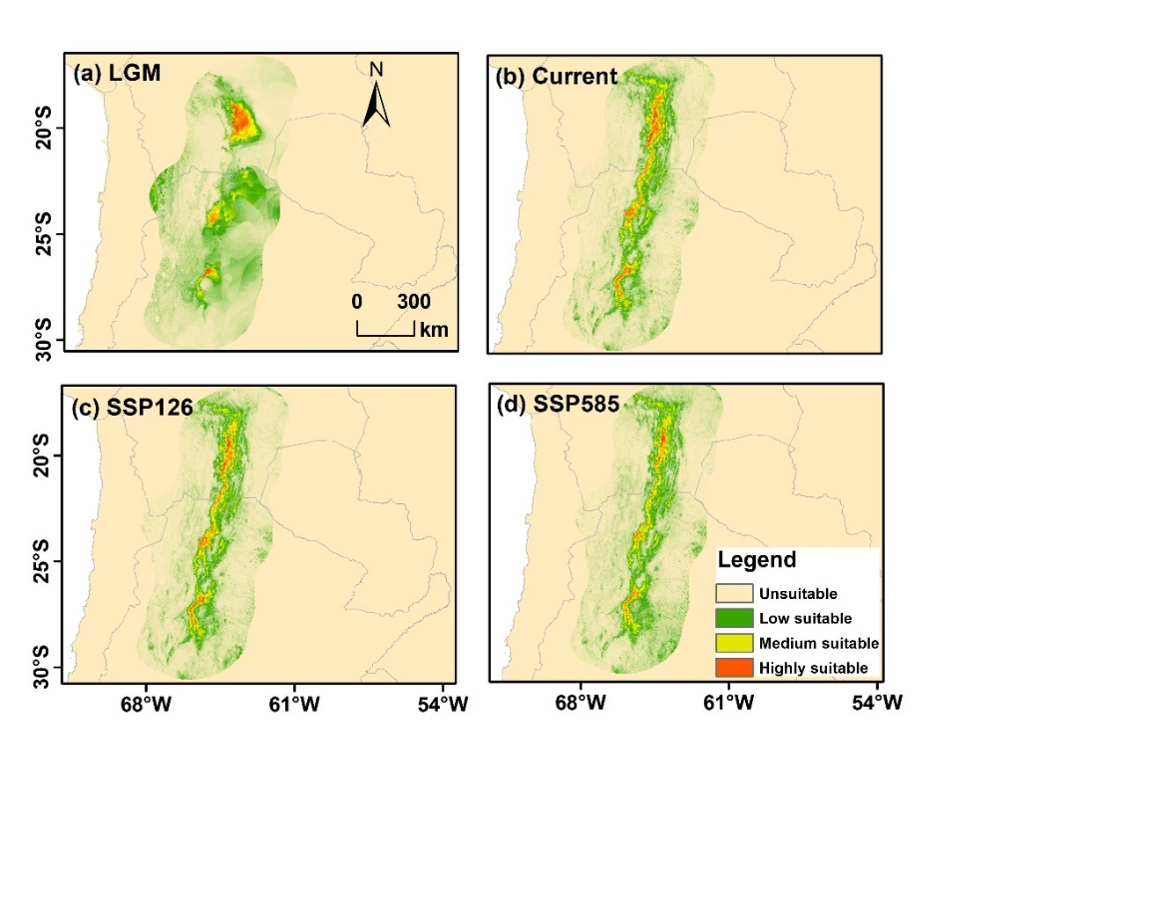

**Fig. A2** Predicted distribution ranges of *J. australis* from past to future. The color gradient from green to red represents low to high suitability. (a) represent LGM, Last Glacial Maximum, (b) current period, (c) SSP126 (2090), and SSP5858 (2090).

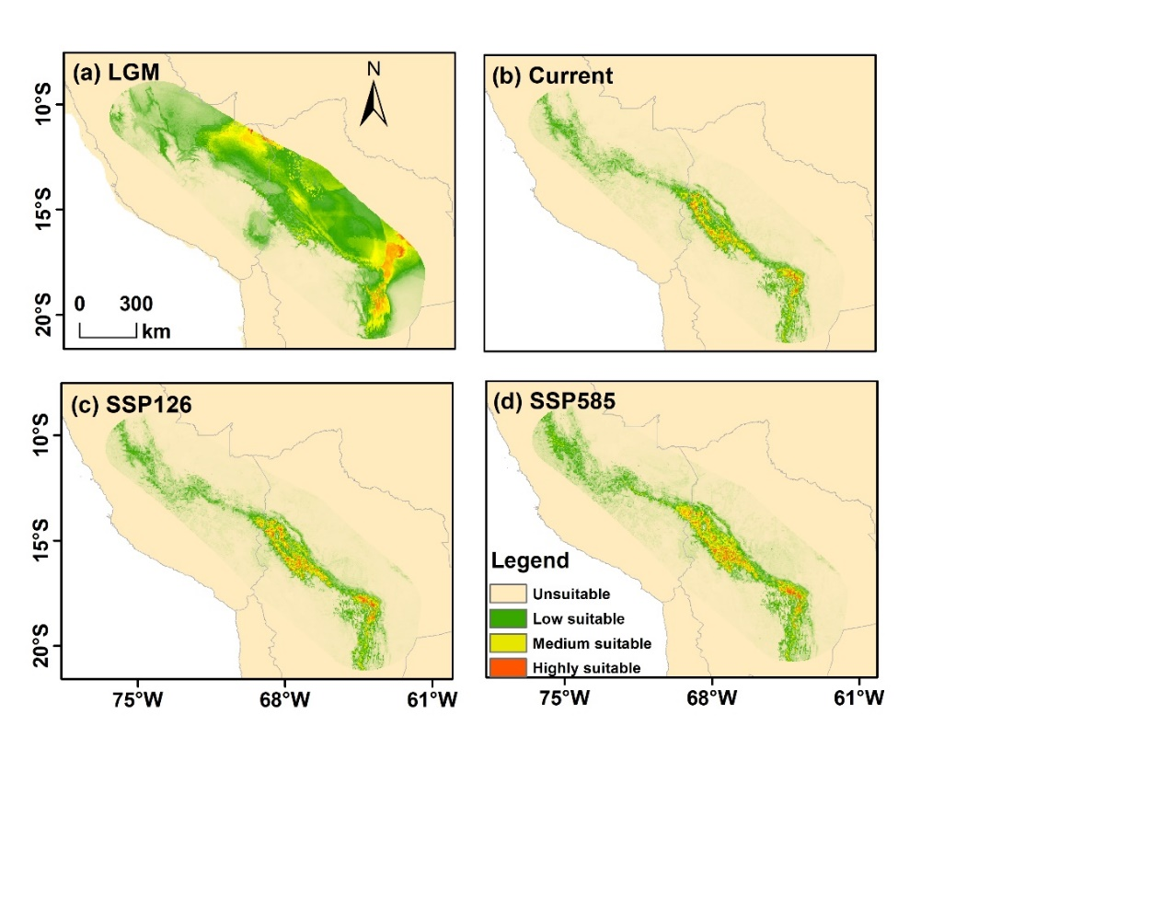

**Fig. A3** Predicted distribution ranges of *J. boliviana* from past to future. The color gradient from green to red represents low to high suitability. (a) represent LGM, Last Glacial Maximum, (b) current period, (c) SSP126 (2090), and SSP5858 (2090).

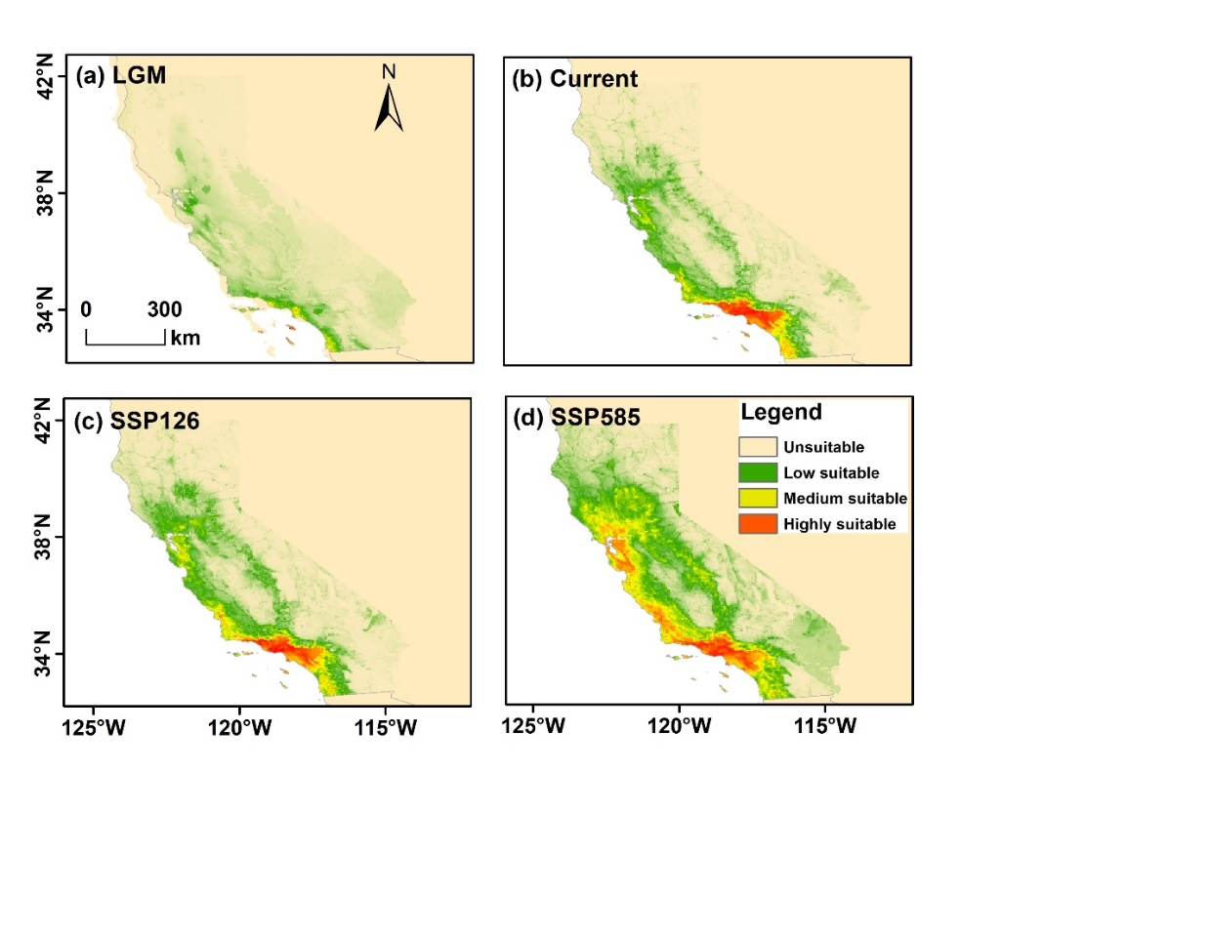

**Fig. A4** Predicted distribution ranges of *J. californica* from past to future. The color gradient from green to red represents low to high suitability. (a) represent LGM, Last Glacial Maximum, (b) current period, (c) SSP126 (2090), and SSP5858 (2090).

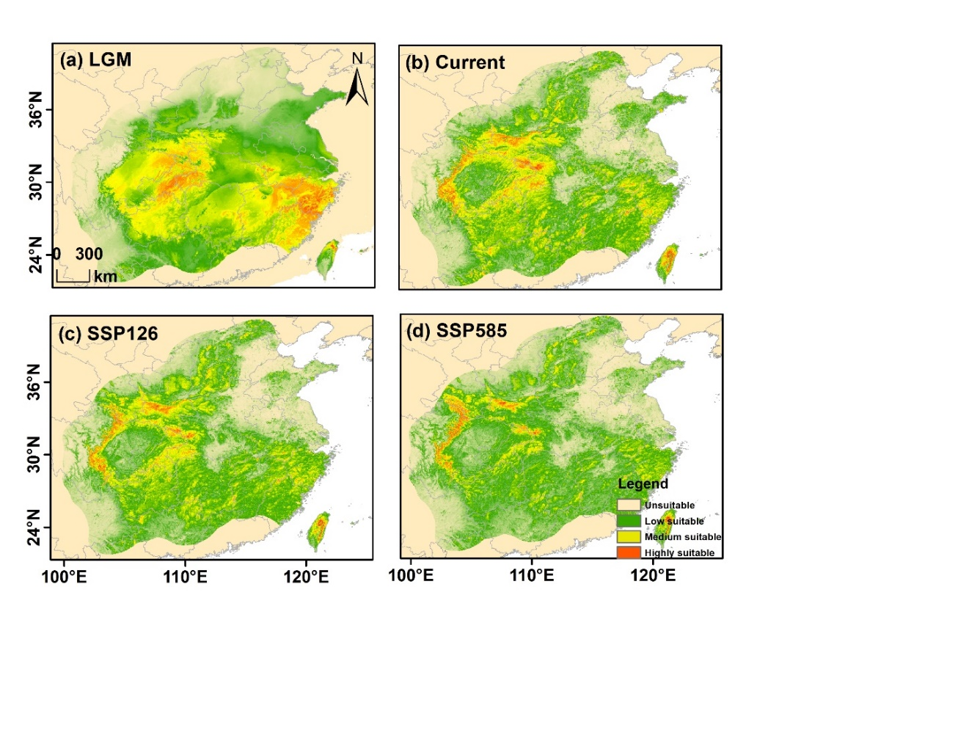

**Fig. A5** Predicted distribution ranges of *J. cathayensis* from past to future. The color gradient from green to red represents low to high suitability. (a) represent LGM, Last Glacial Maximum, (b) current period, (c) SSP126 (2090), and SSP5858 (2090).

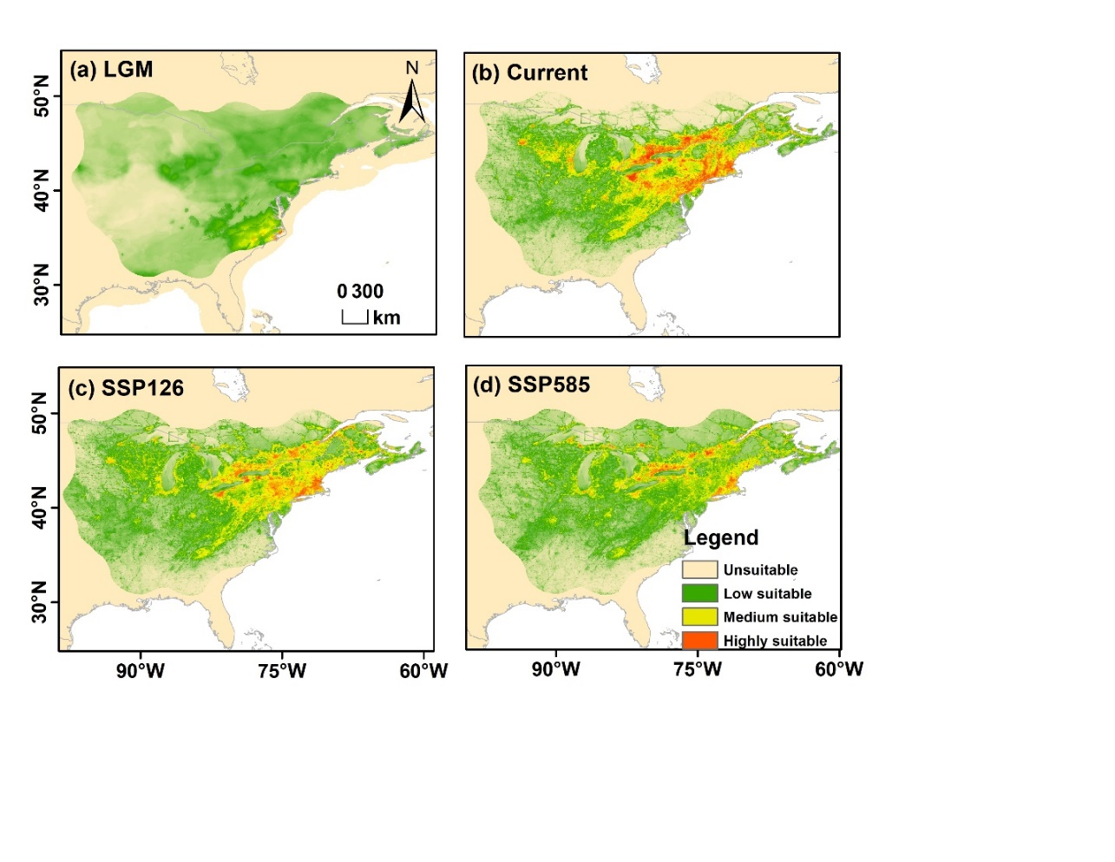

**Fig. A6** Predicted distribution ranges of *J. cinerea* from past to future. The color gradient from green to red represents low to high suitability. (a) represent LGM, Last Glacial Maximum, (b) current period, (c) SSP126 (2090), and SSP5858 (2090).

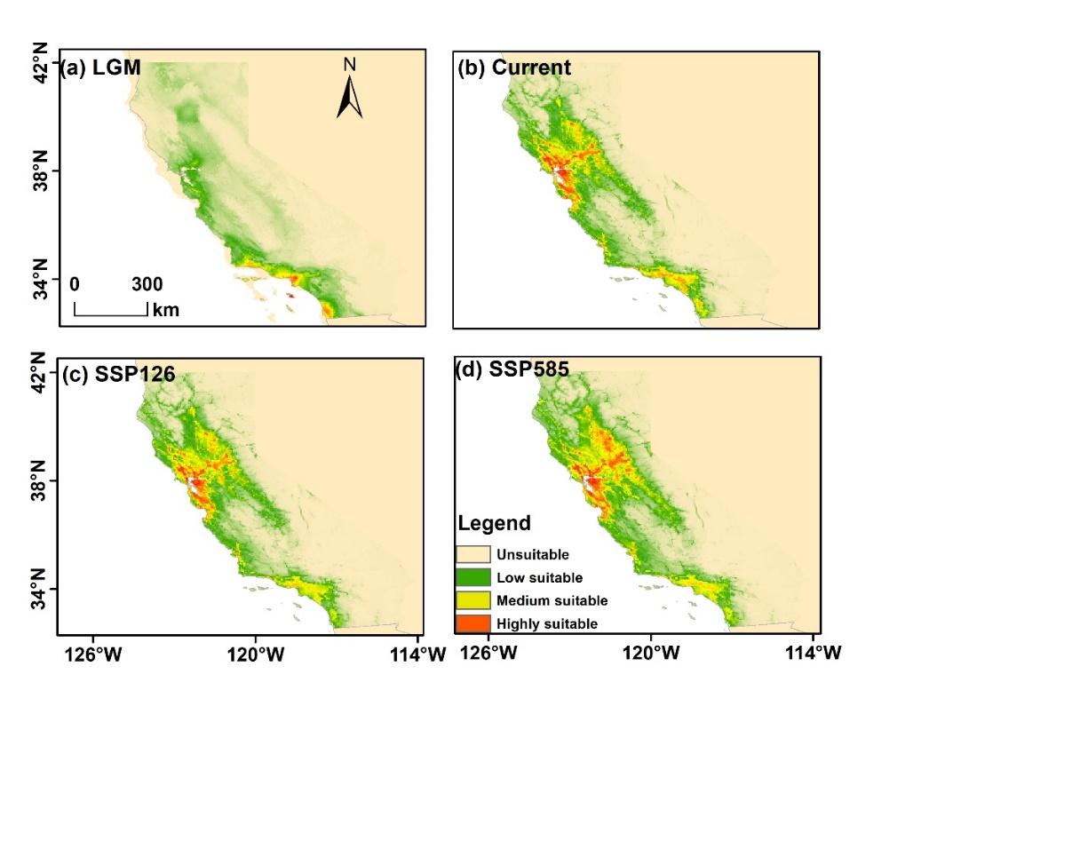

**Fig. A7** Predicted distribution ranges of *J. hindsii* from past to future. The color gradient from green to red represents low to high suitability. (a) represent LGM, Last Glacial Maximum, (b) current period, (c) SSP126 (2090), and SSP5858 (2090).

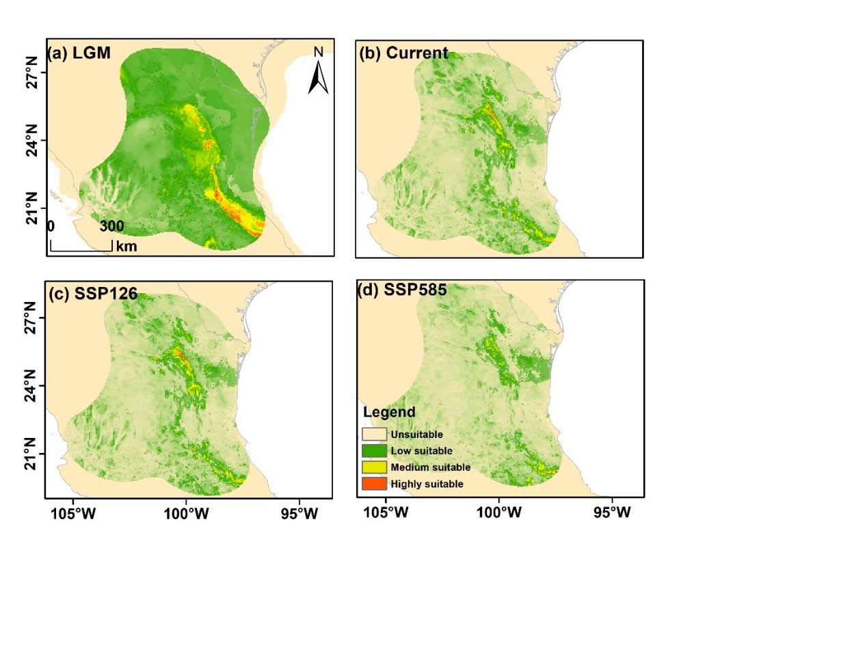

**Fig. A8** Predicted distribution ranges of *J. hirsuta* from past to future. The color gradient from green to red represents low to high suitability. (a) represent LGM, Last Glacial Maximum, (b) current period, (c) SSP126 (2090), and SSP5858 (2090).

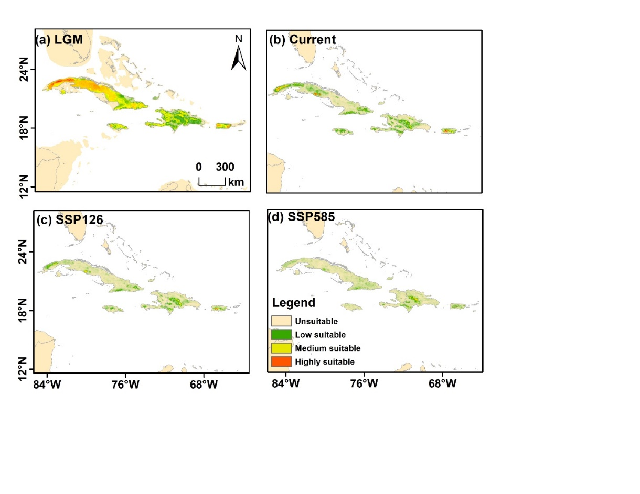

**Fig. A9** Predicted distribution ranges of *J. jamaicensis* from past to future. The color gradient from green to red represents low to high suitability. (a) represent LGM, Last Glacial Maximum, (b) current period, (c) SSP126 (2090), and SSP5858 (2090).

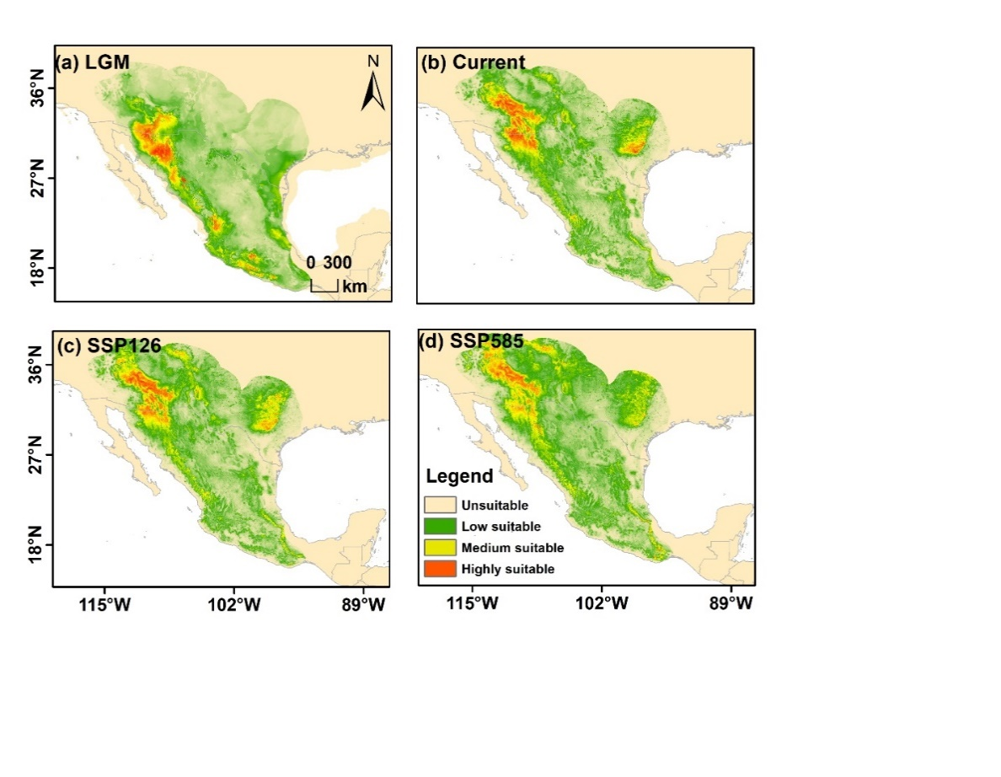

**Fig. A10** Predicted distribution ranges of *J. major* from past to future. The color gradient from green to red represents low to high suitability. (a) represent LGM, Last Glacial Maximum, (b) current period, (c) SSP126 (2090), and SSP5858 (2090).

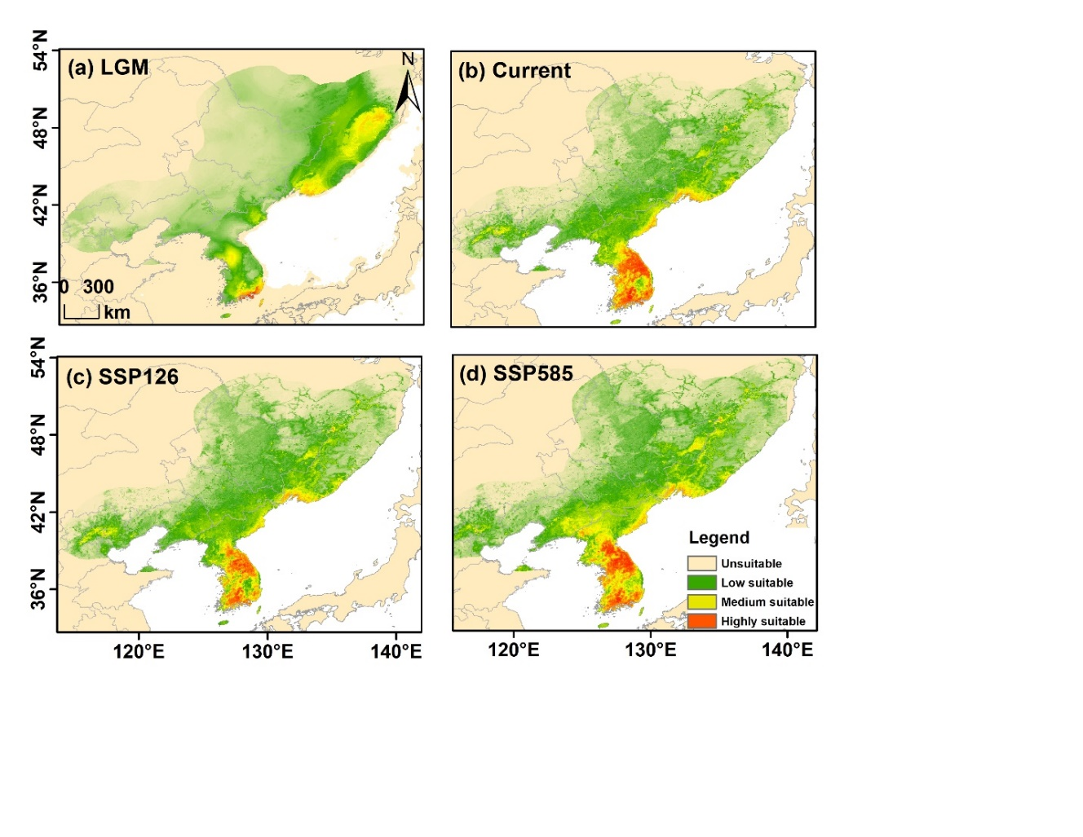

**Fig. A11** Predicted distribution ranges of *J. mandshurica* from past to future. The color gradient from green to red represents low to high suitability. (a) represent LGM, Last Glacial Maximum, (b) current period, (c) SSP126 (2090), and SSP5858 (2090).

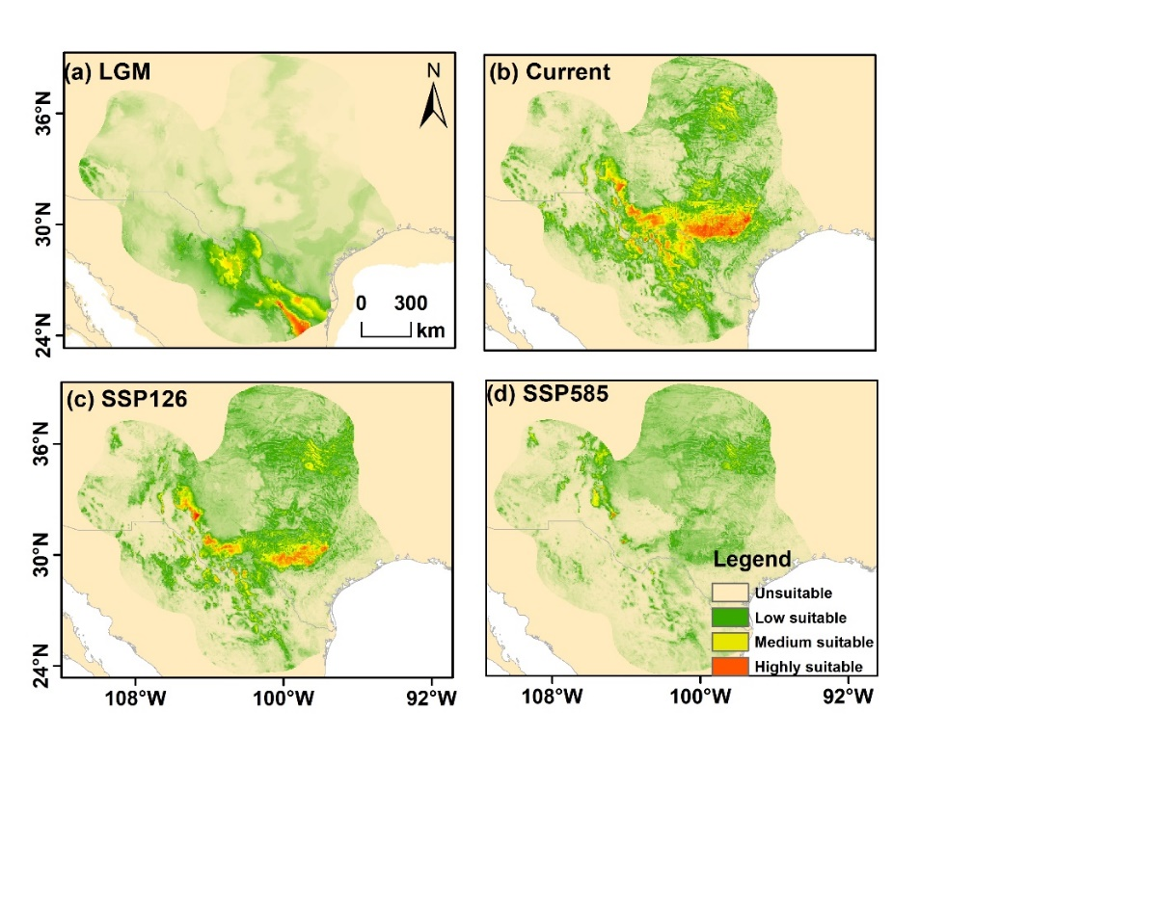

**Fig. A12** Predicted distribution ranges of *J. macrocarpa* from past to future. The color gradient from green to red represents low to high suitability. (a) represent LGM, Last Glacial Maximum, (b) current period, (c) SSP126 (2090), and SSP5858 (2090).

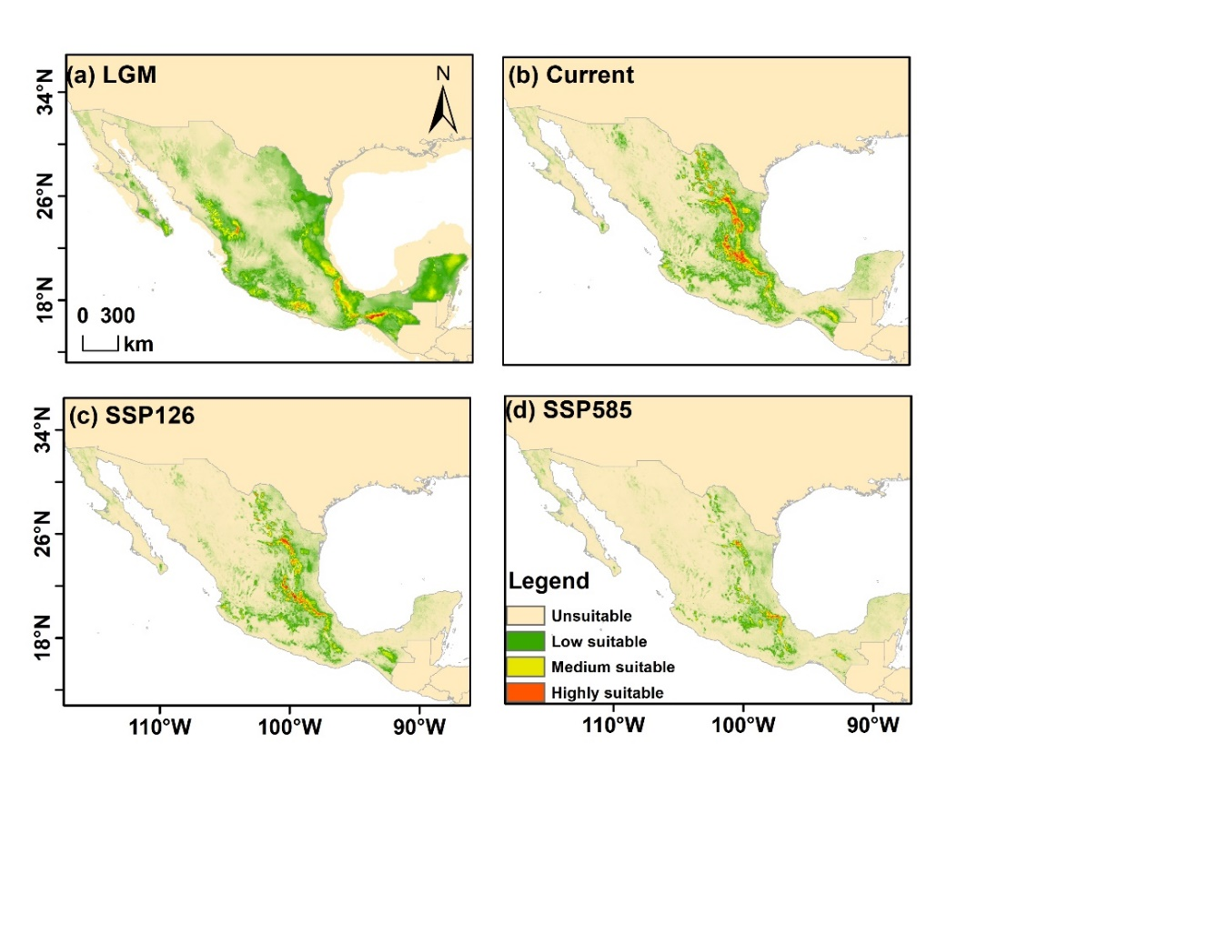

**Fig. A13** Predicted distribution ranges of *J. mollis* from past to future. The color gradient from green to red represents low to high suitability. (a) represent LGM, Last Glacial Maximum, (b) current period, (c) SSP126 (2090), and SSP5858 (2090).

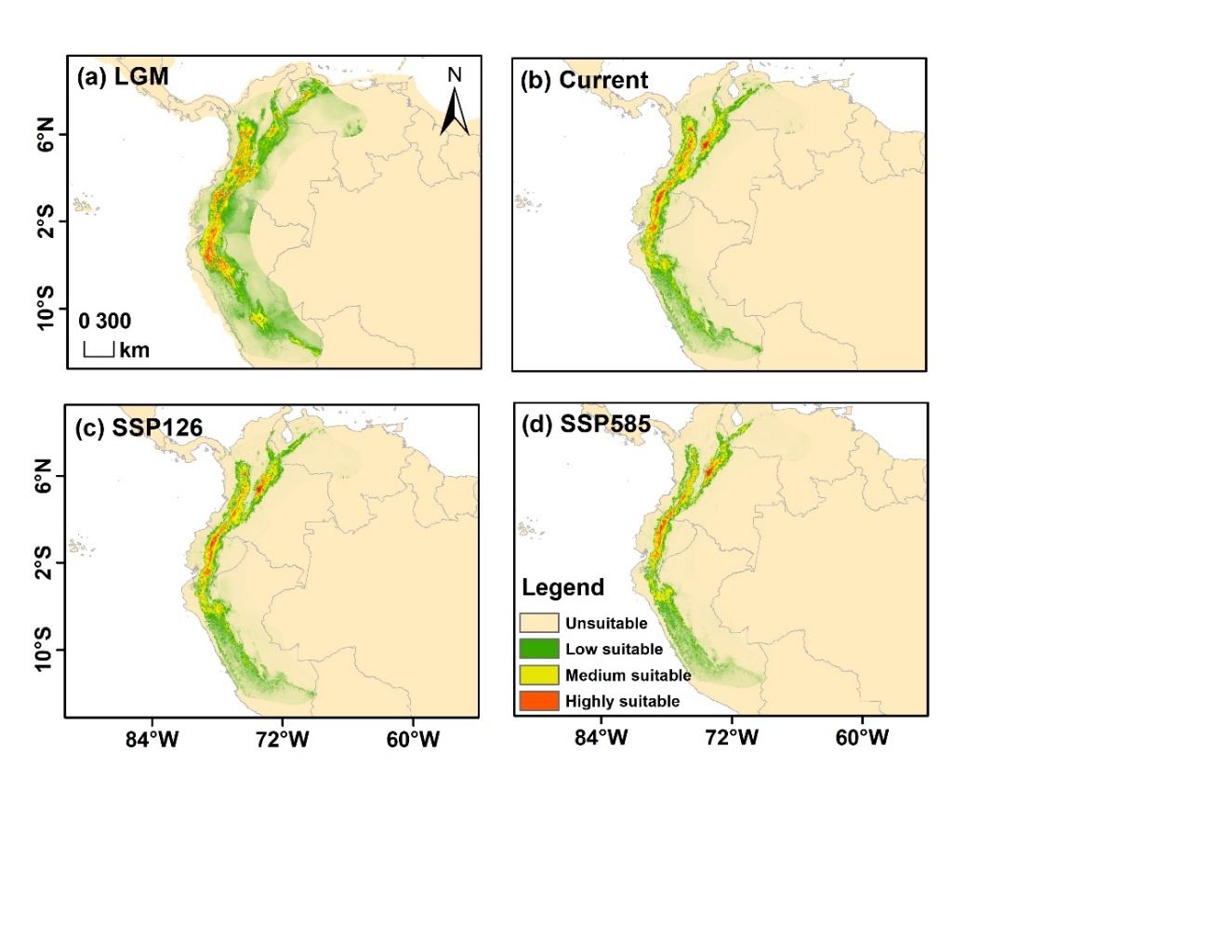

**Fig. A14** Predicted distribution ranges of *J. neotropica* from past to future. The color gradient from green to red represents low to high suitability. (a) represent LGM, Last Glacial Maximum, (b) current period, (c) SSP126 (2090), and SSP5858 (2090).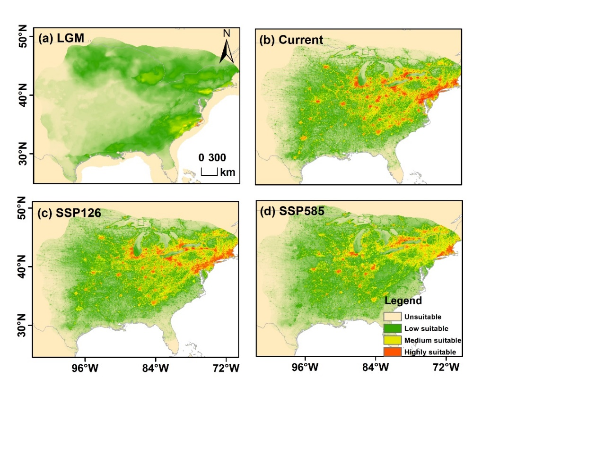

**Fig. A15** Predicted distribution ranges of *J. nigra* from past to future. The color gradient from green to red represents low to high suitability. (a) represent LGM, Last Glacial Maximum, (b) current period, (c) SSP126 (2090), and SSP5858 (2090).

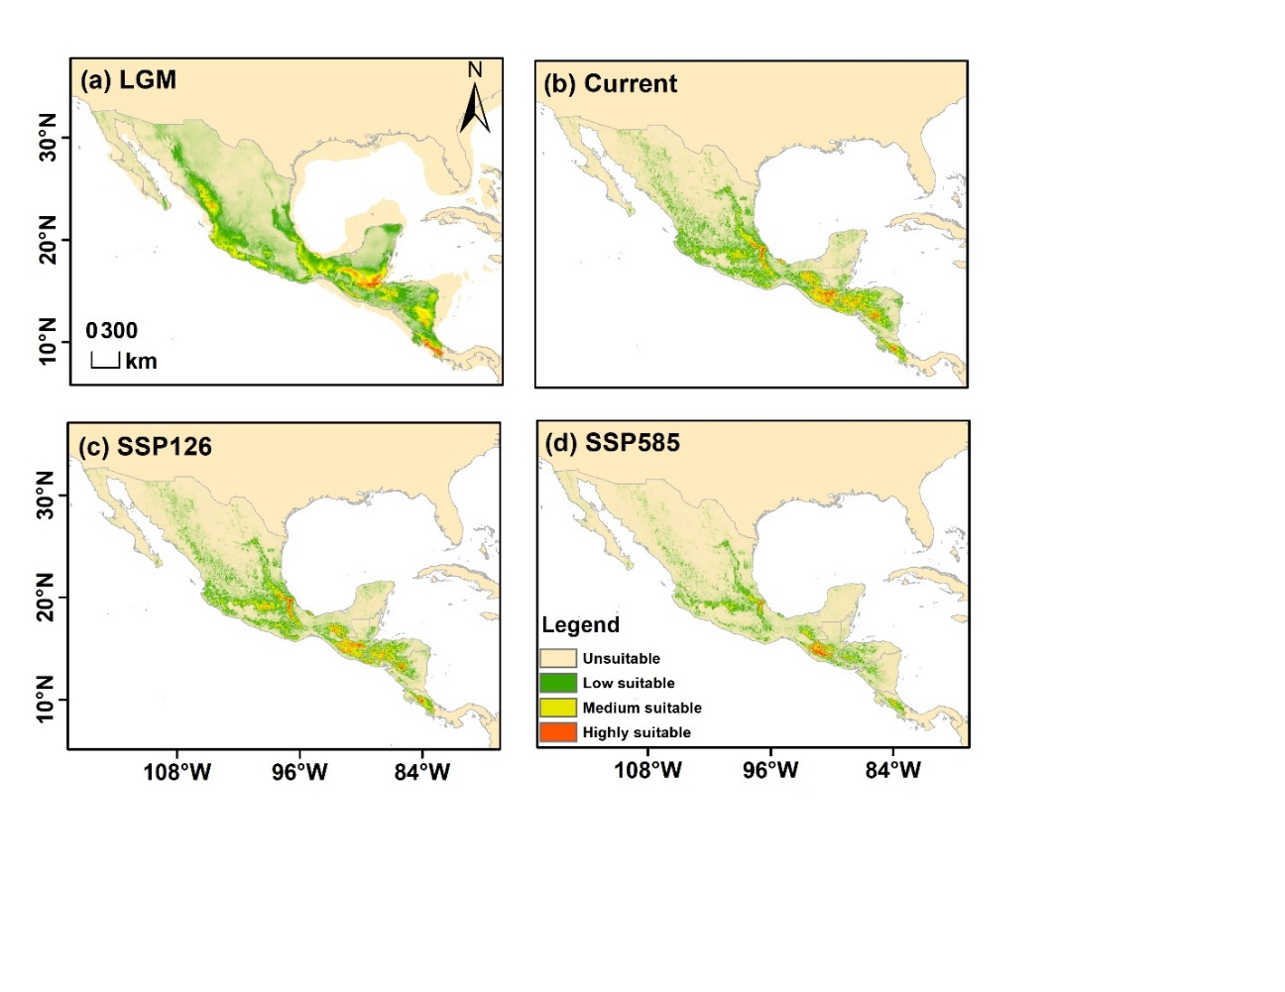

**Fig. A16** Predicted distribution ranges of *J. pyriformis* from past to future. The color gradient from green to red represents low to high suitability. (a) represent LGM, Last Glacial Maximum, (b) current period, (c) SSP126 (2090), and SSP5858 (2090).

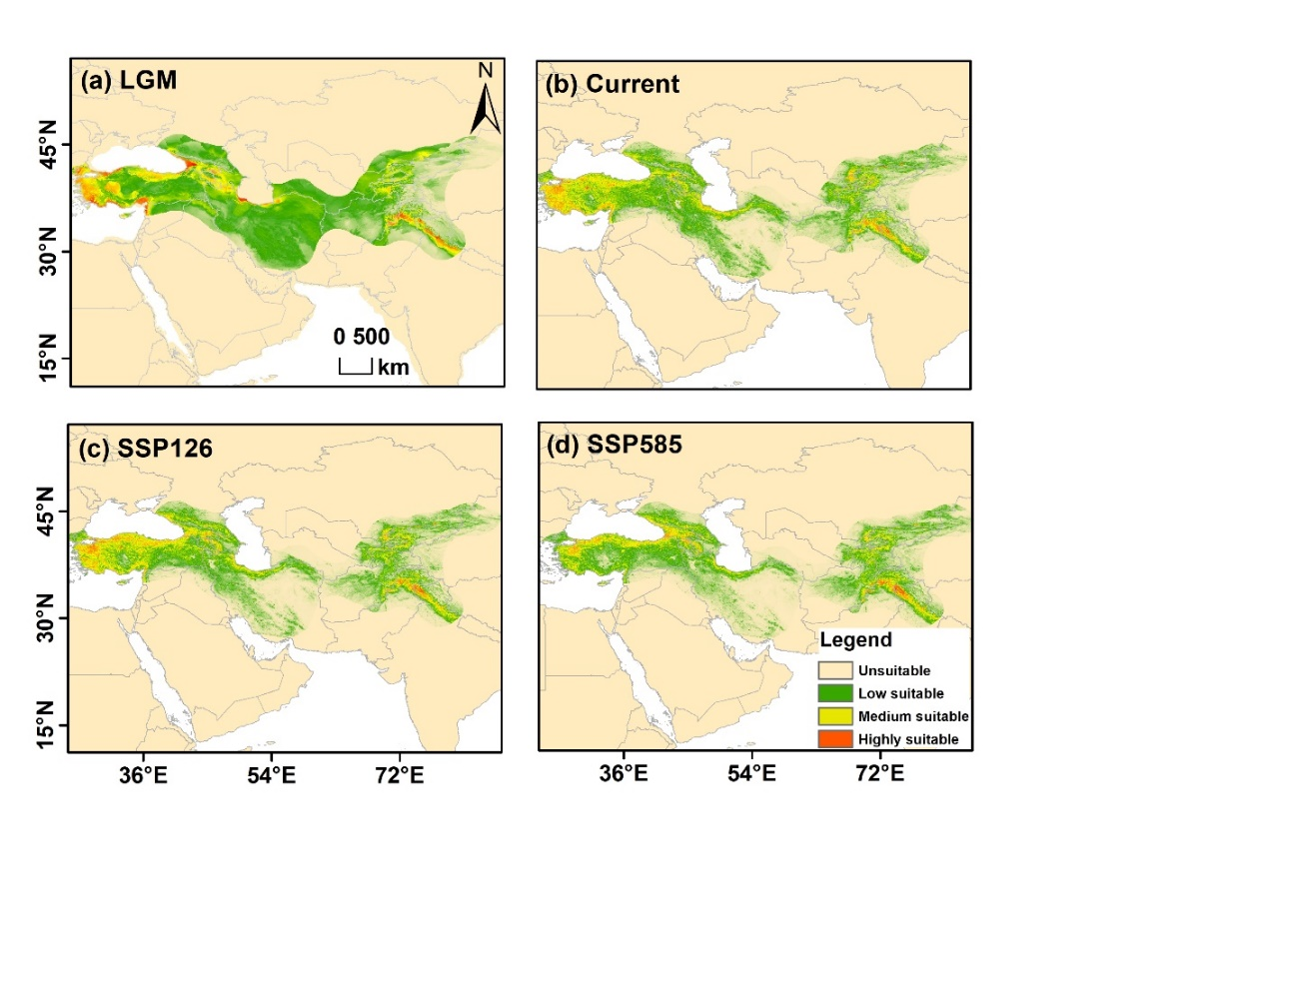

**Fig. A17** Predicted distribution ranges of *J. regia* from past to future. The color gradient from green to red represents low to high suitability. (a) represent LGM, Last Glacial Maximum, (b) current period, (c) SSP126 (2090), and SSP5858 (2090).

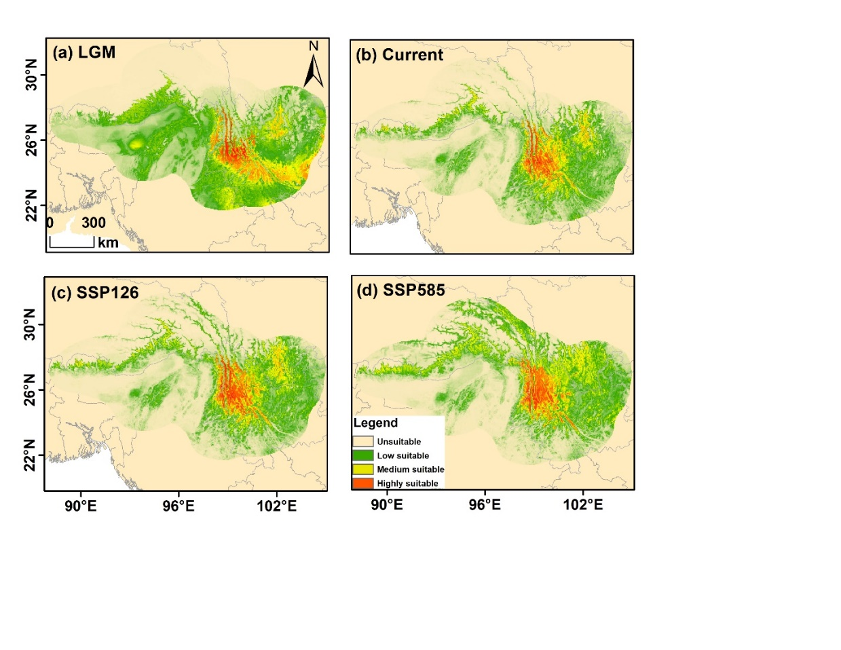

**Fig. A18** Predicted distribution ranges of *J. sigillata* from past to future. The color gradient from green to red represents low to high suitability. (a) represent LGM, Last Glacial Maximum, (b) current period, (c) SSP126 (2090), and SSP5858 (2090).

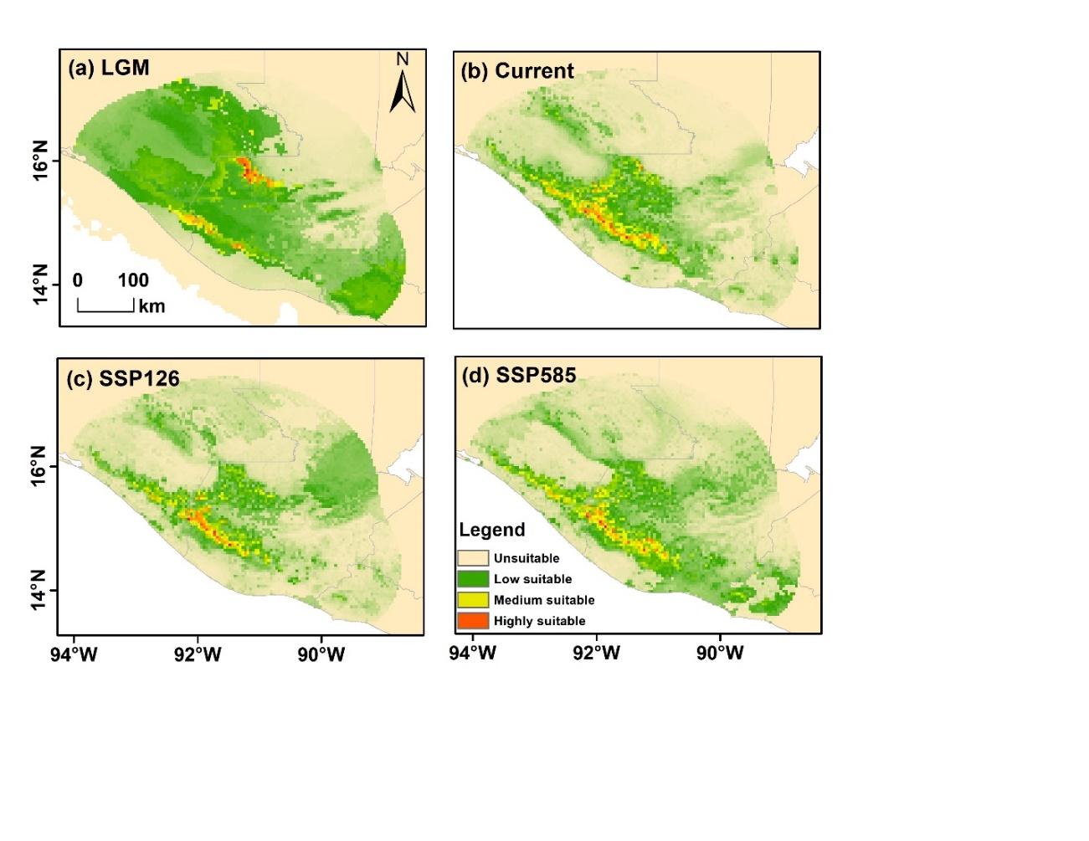

**Fig. A19** Predicted distribution ranges of *J. steyermarkii* from past to future. The color gradient from green to red represents low to high suitability. (a) represent LGM, Last Glacial Maximum, (b) current period, (c) SSP126 (2090), and SSP5858 (2090).

***Carya* genus**

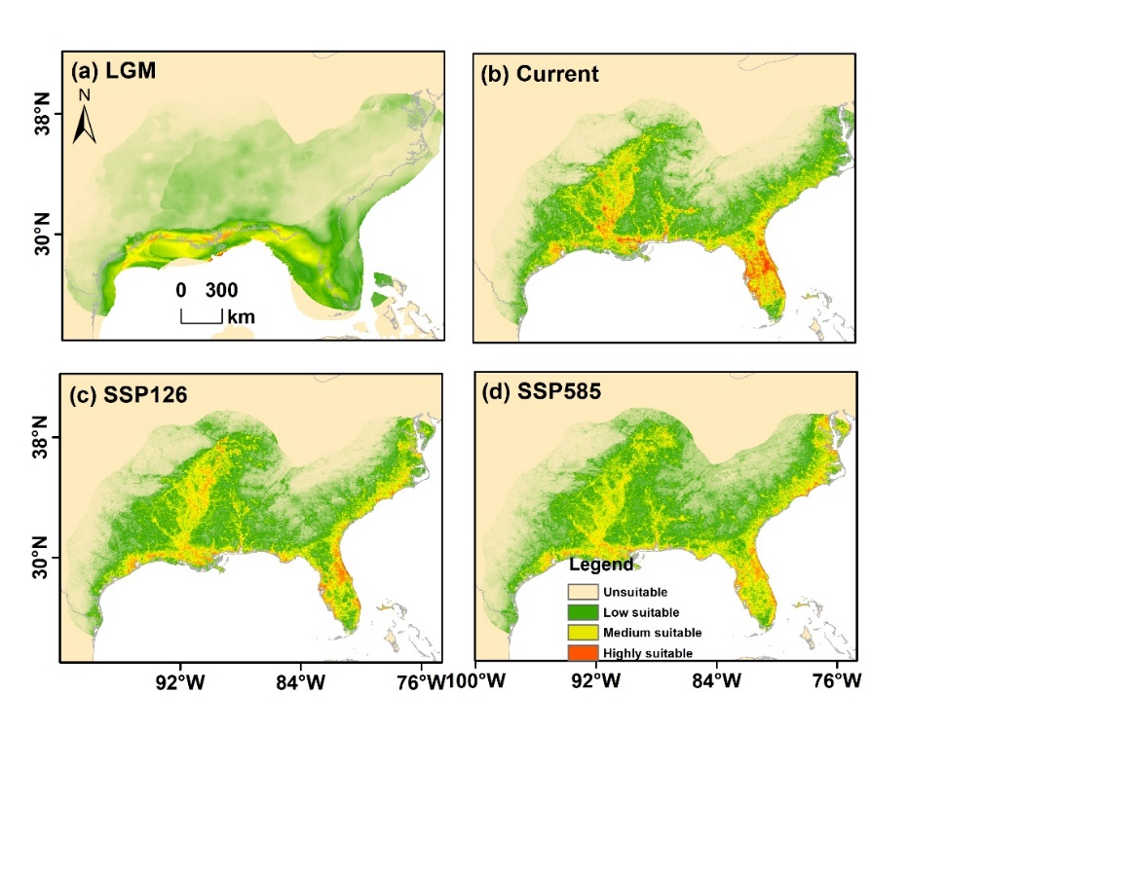

**Fig. A20** Predicted distribution ranges of *C. aquatica* from past to future. The color gradient from green to red represents low to high suitability. (a) represent LGM, Last Glacial Maximum, (b) current period, (c) SSP126 (2090), and SSP5858 (2090).

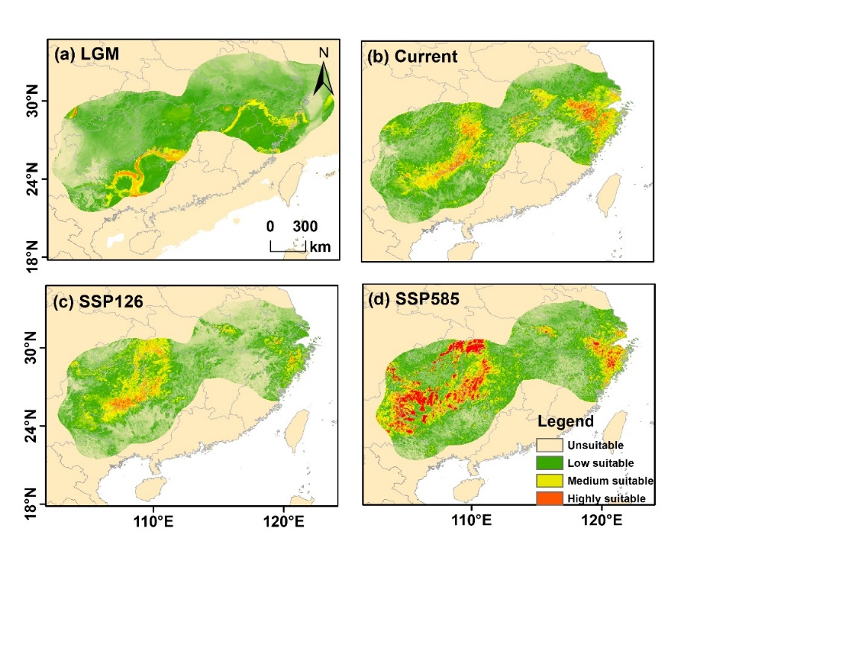

**Fig. A21** Predicted distribution ranges of *C. cathayensis* from past to future. The color gradient from green to red represents low to high suitability. (a) represent LGM, Last Glacial Maximum, (b) current period, (c) SSP126 (2090), and SSP5858 (2090).

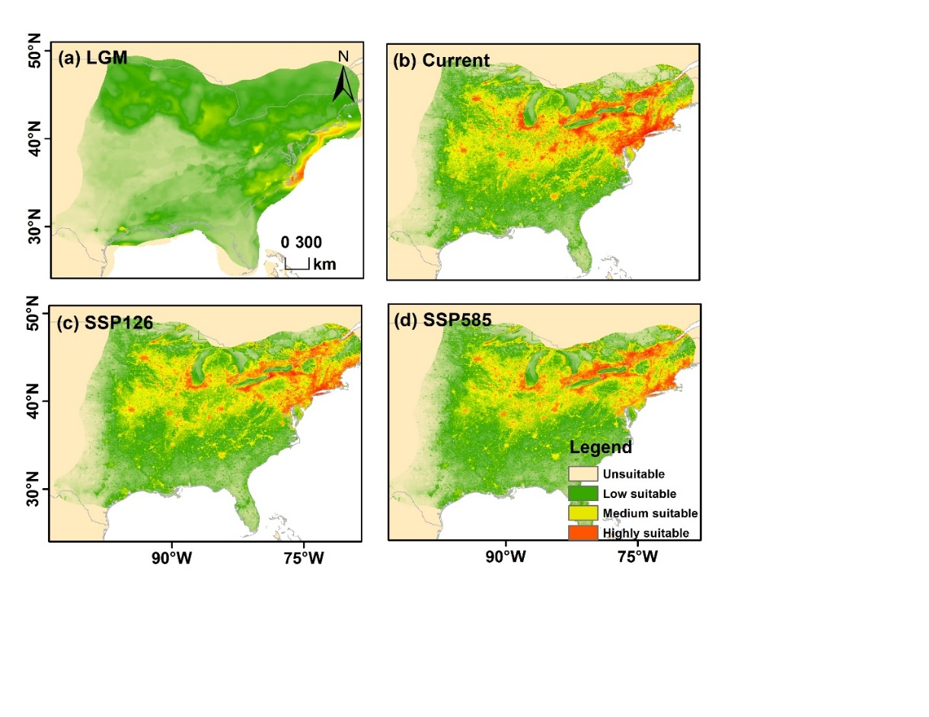

**Fig. A22** Predicted distribution ranges of *C. cordiformis* from past to future. The color gradient from green to red represents low to high suitability. (a) represent LGM, Last Glacial Maximum, (b) current period, (c) SSP126 (2090), and SSP5858 (2090).

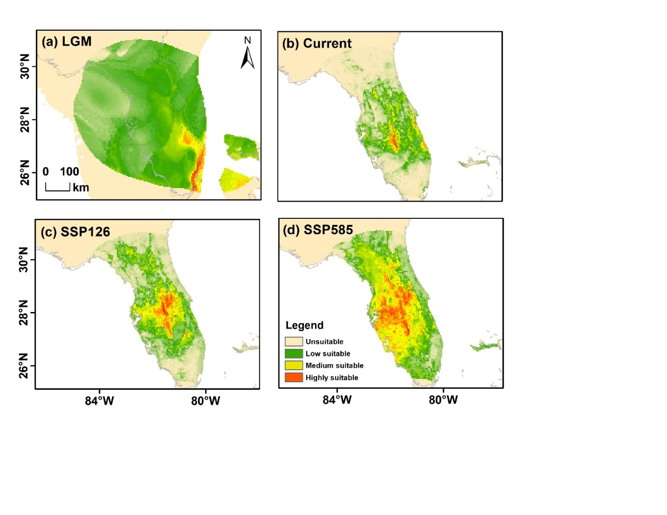

**Fig. A23** Predicted distribution ranges of *C. floridana* from past to future. The color gradient from green to red represents low to high suitability. (a) represent LGM, Last Glacial Maximum, (b) current period, (c) SSP126 (2090), and SSP5858 (2090).

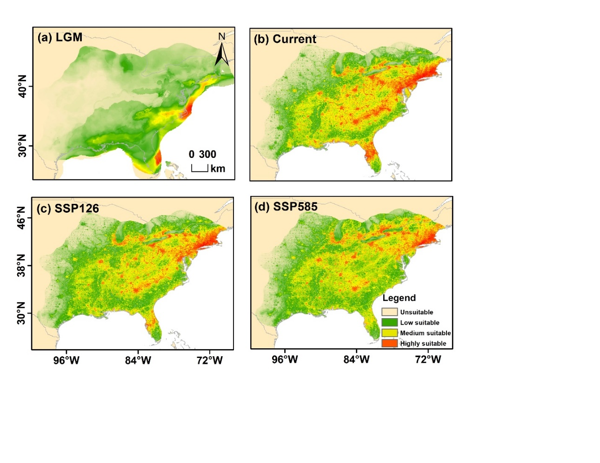

**Fig. A24** Predicted distribution ranges of *C. glabra* from past to future. The color gradient from green to red represents low to high suitability. (a) represent LGM, Last Glacial Maximum, (b) current period, (c) SSP126 (2090), and SSP5858 (2090).

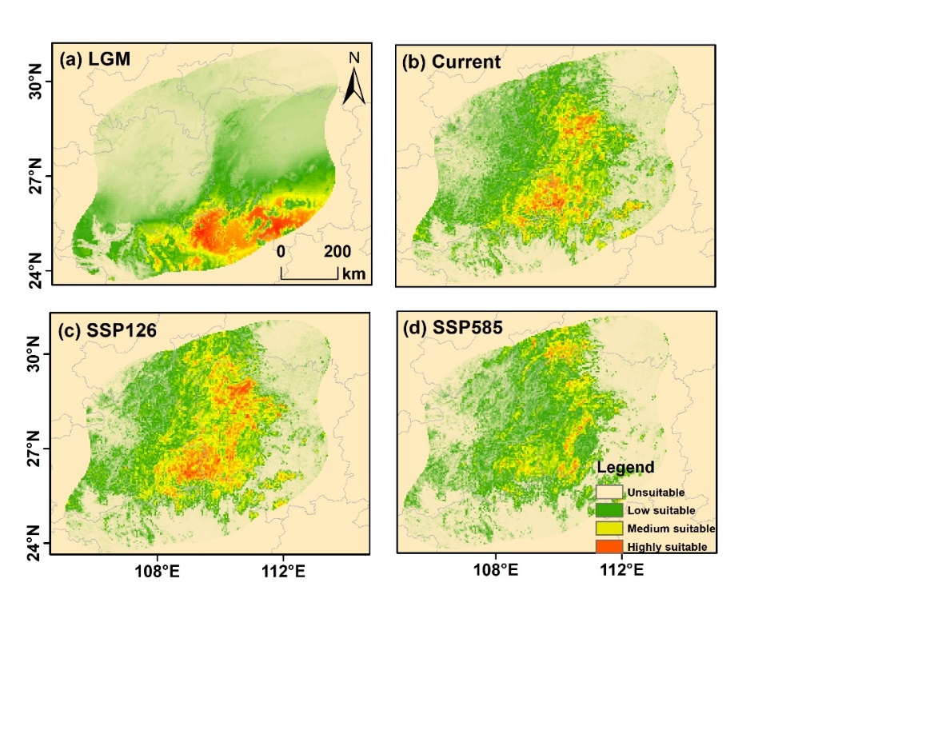

**Fig. A25** Predicted distribution ranges of *C. hunanensis* from past to future. The color gradient from green to red represents low to high suitability. (a) represent LGM, Last Glacial Maximum, (b) current period, (c) SSP126 (2090), and SSP5858 (2090).

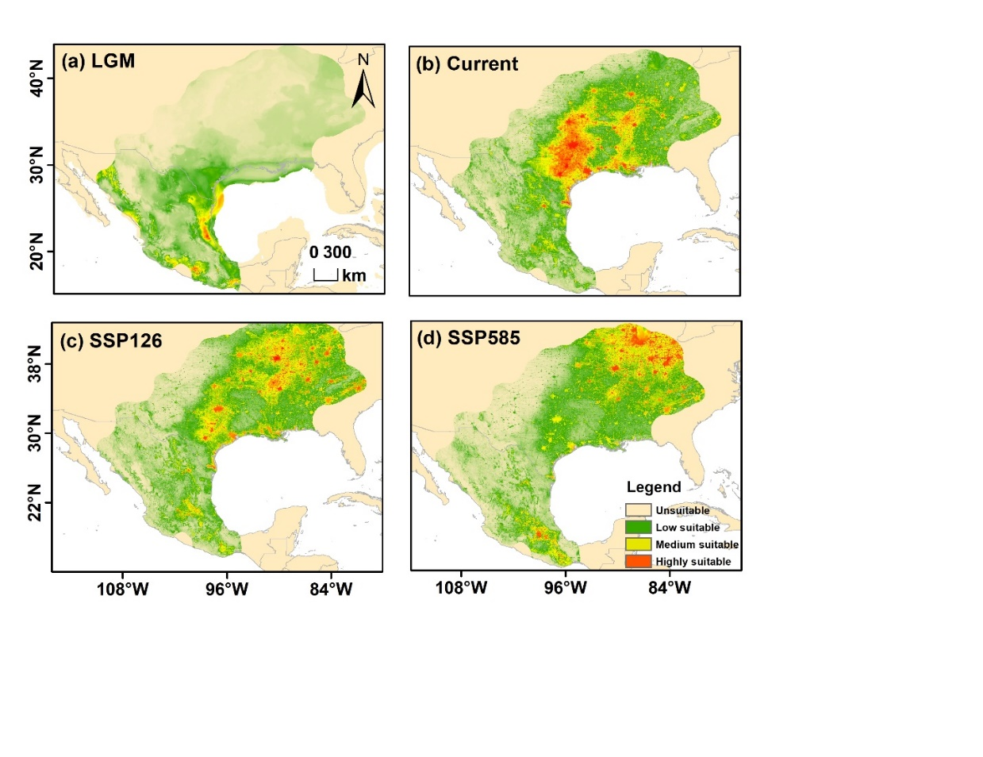

**Fig. A26** Predicted distribution ranges of *C. illinoinensis* from past to future. The color gradient from green to red represents low to high suitability. (a) represent LGM, Last Glacial Maximum, (b) current period, (c) SSP126 (2090), and SSP5858 (2090).

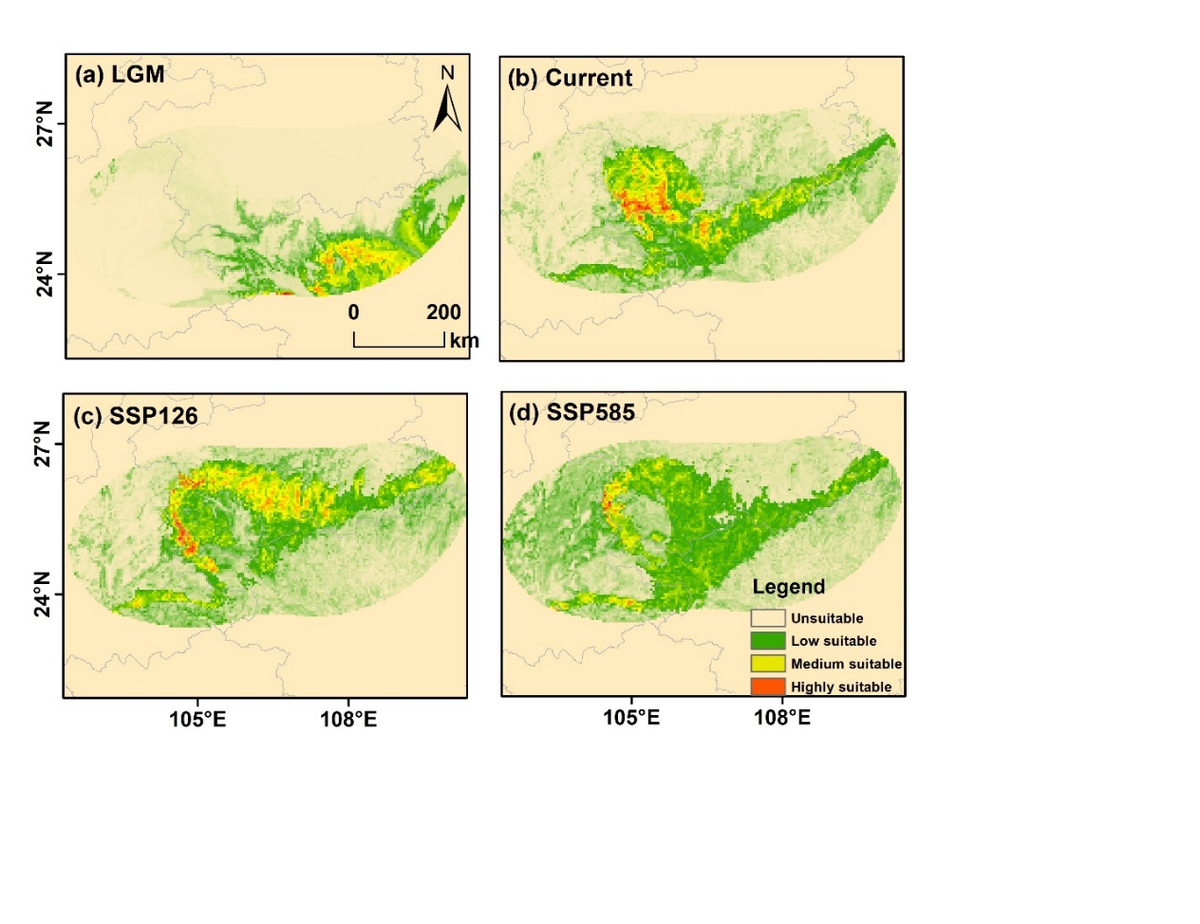

**Fig. A27** Predicted distribution ranges of *C. kweichowensis*from past to future. The color gradient from green to red represents low to high suitability. (a) represent LGM, Last Glacial Maximum, (b) current period, (c) SSP126 (2090), and SSP5858 (2090).

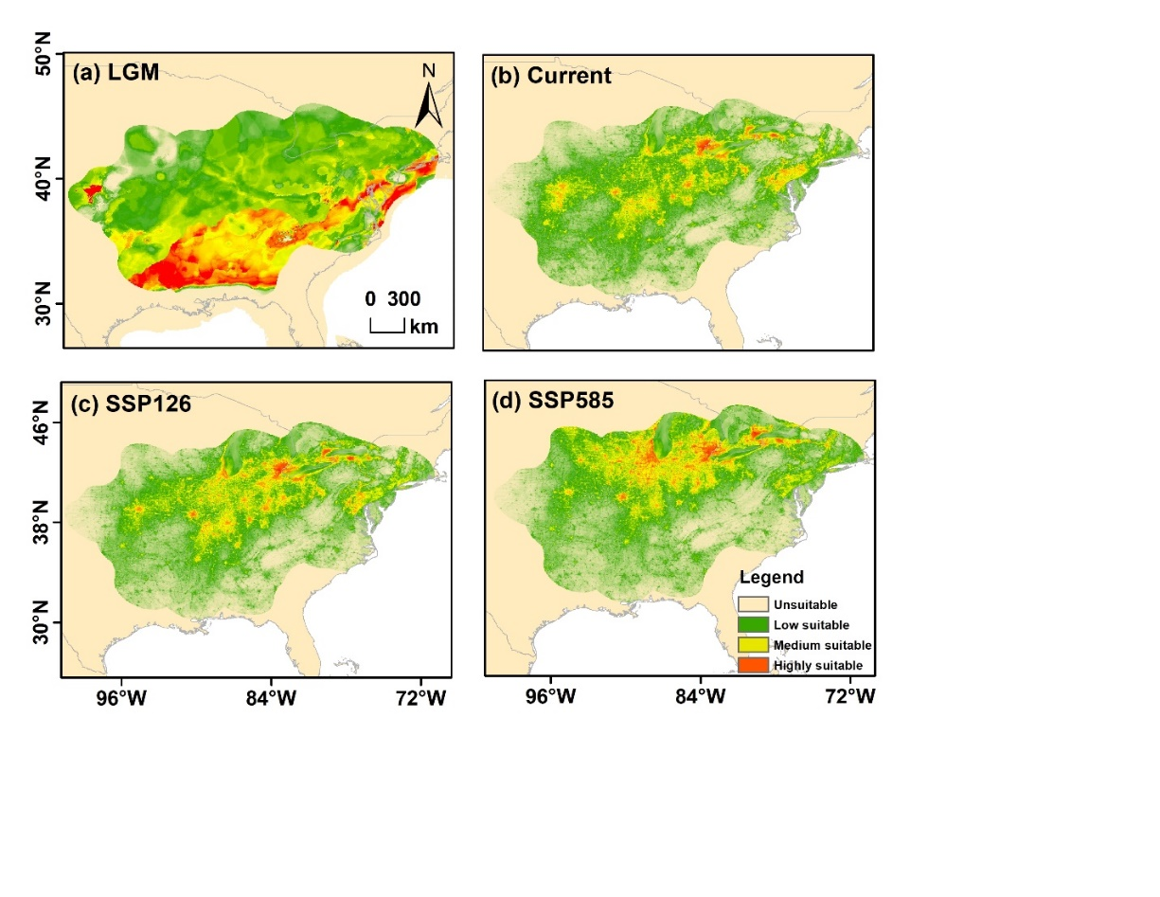

**Fig. A28** Predicted distribution ranges of *C. laciniosa* from past to future. The color gradient from green to red represents low to high suitability. (a) represent LGM, Last Glacial Maximum, (b) current period, (c) SSP126 (2090), and SSP5858 (2090).

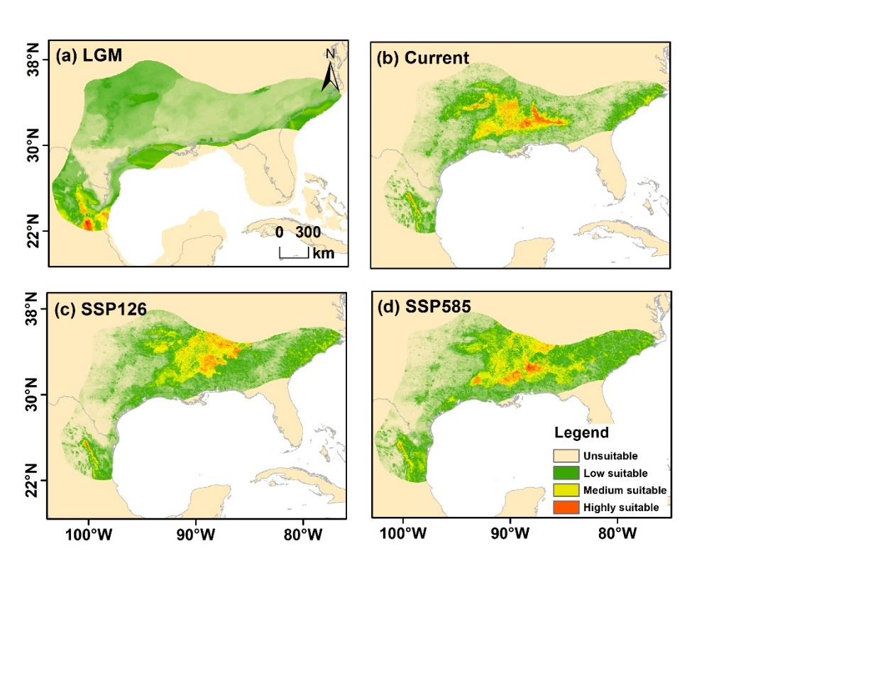

**Fig. A29** Predicted distribution ranges of *C. myristiciformis* from past to future. The color gradient from green to red represents low to high suitability. (a) represent LGM, Last Glacial Maximum, (b) current period, (c) SSP126 (2090), and SSP5858 (2090).

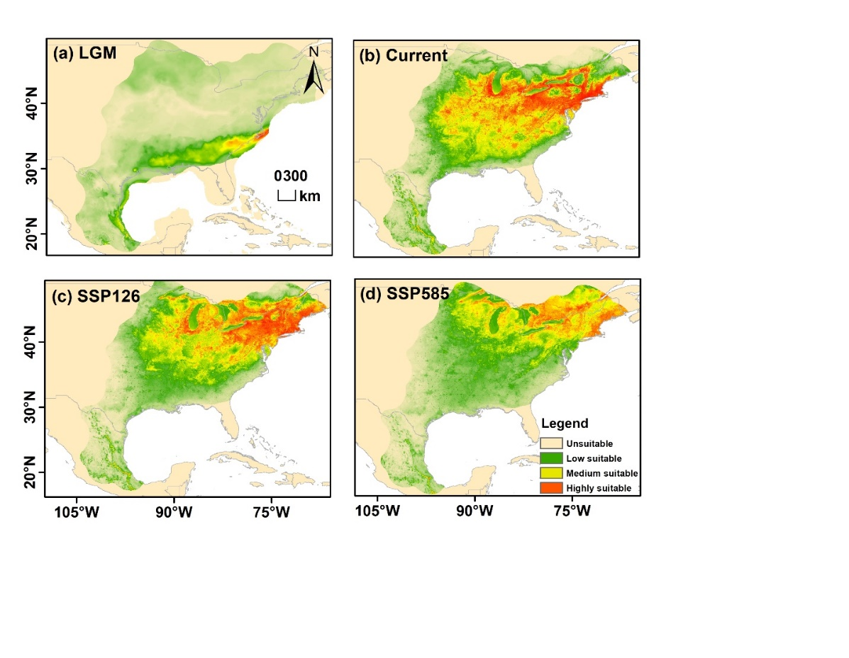

**Fig. A30** Predicted distribution ranges of *C. ovata* from past to future. The color gradient from green to red represents low to high suitability. (a) represent LGM, Last Glacial Maximum, (b) current period, (c) SSP126 (2090), and SSP5858 (2090).

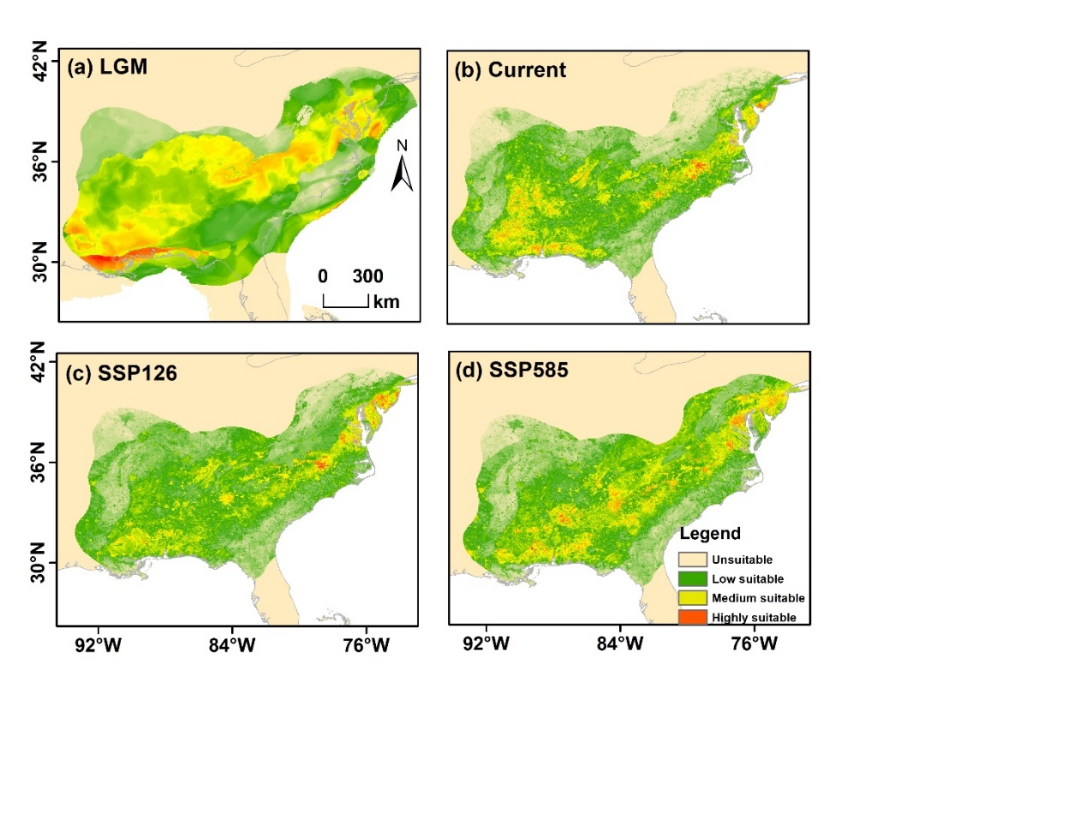

**Fig. A31** Predicted distribution ranges of *C. pallida* from past to future. The color gradient from green to red represents low to high suitability. (a) represent LGM, Last Glacial Maximum, (b) current period, (c) SSP126 (2090), and SSP5858 (2090).

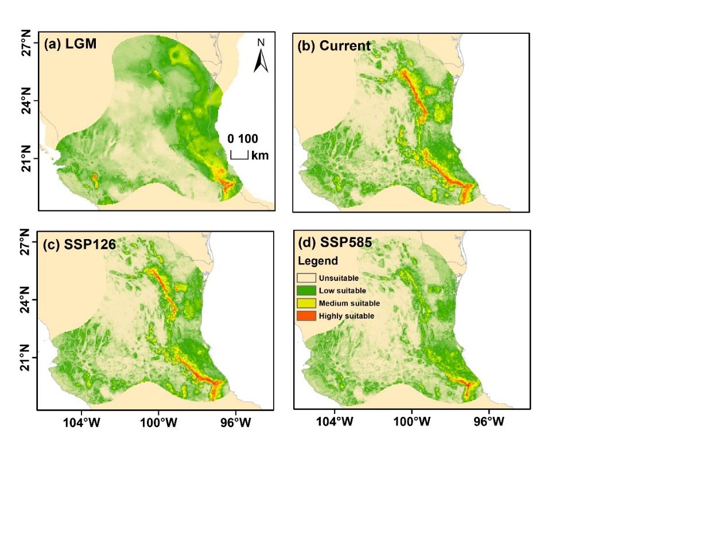

**Fig. A32** Predicted distribution ranges of *C. palmeri* from past to future. The color gradient from green to red represents low to high suitability. (a) represent LGM, Last Glacial Maximum, (b) current period, (c) SSP126 (2090), and SSP5858 (2090).

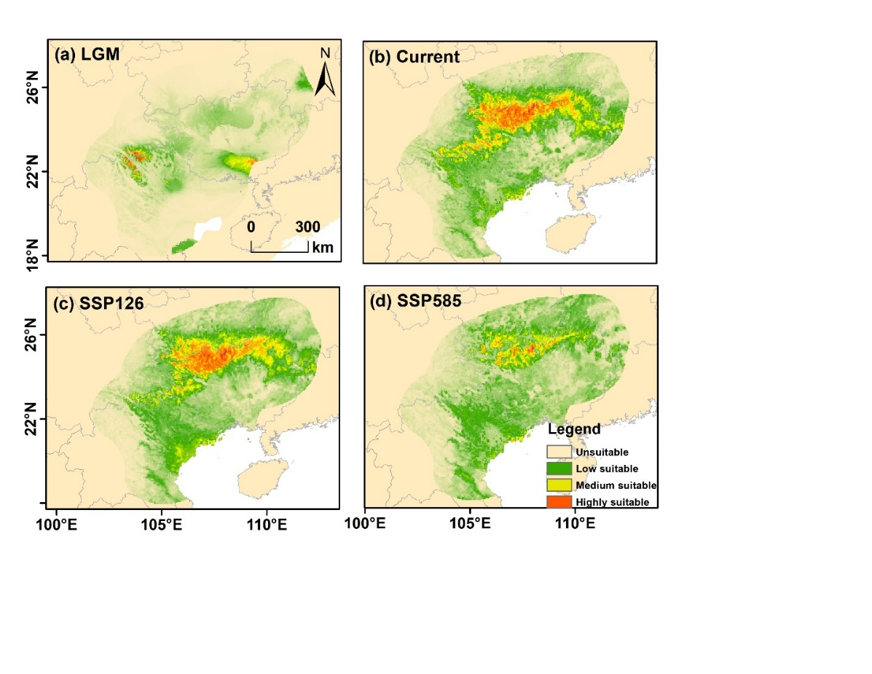

**Fig. A33** Predicted distribution ranges of *C. sinensis* from past to future. The color gradient from green to red represents low to high suitability. (a) represent LGM, Last Glacial Maximum, (b) current period, (c) SSP126 (2090), and SSP5858 (2090).

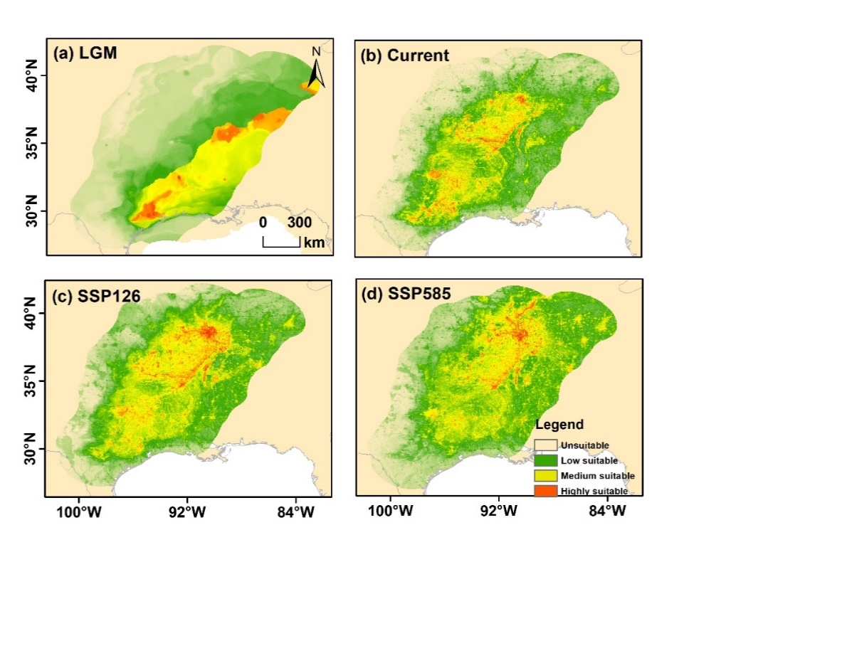

**Fig. A34** Predicted distribution ranges of *C. texana* from past to future. The color gradient from green to red represents low to high suitability. (a) represent LGM, Last Glacial Maximum, (b) current period, (c) SSP126 (2090), and SSP5858 (2090).

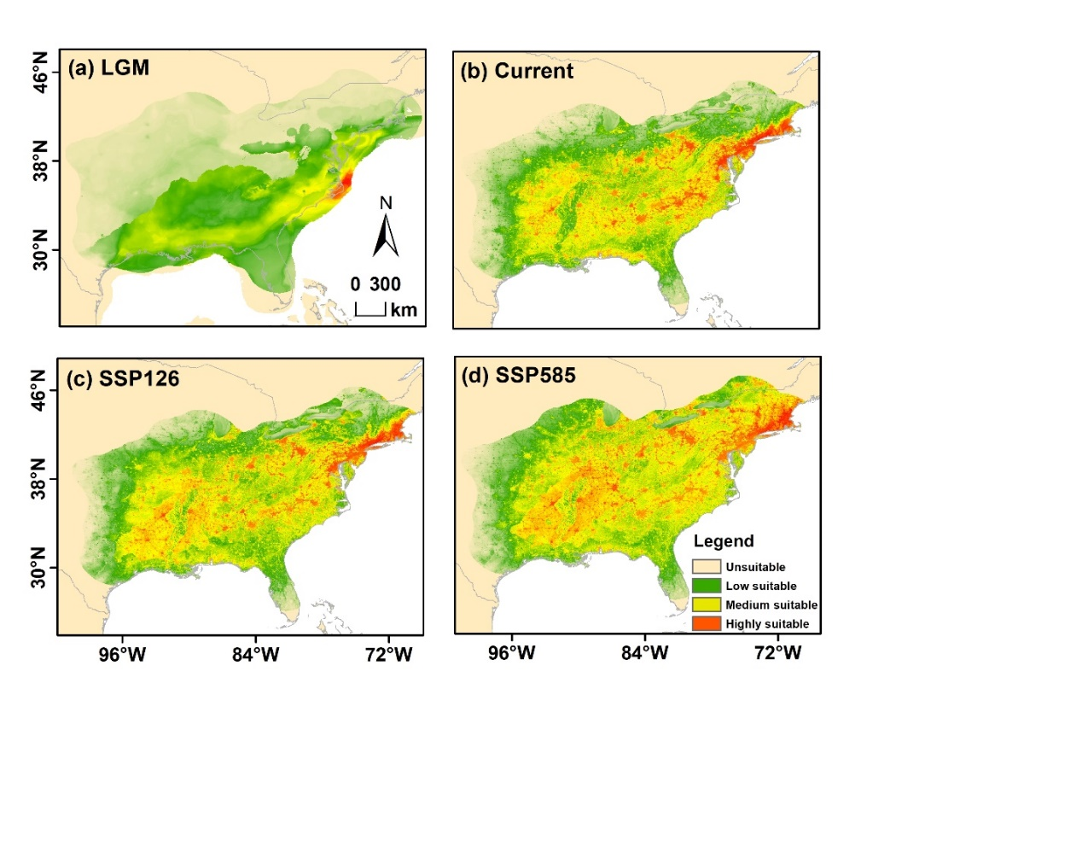

**Fig. A35** Predicted distribution ranges of *C. tomentosa* from past to future. The color gradient from green to red represents low to high suitability. (a) represent LGM, Last Glacial Maximum, (b) current period, (c) SSP126 (2090), and SSP5858 (2090).

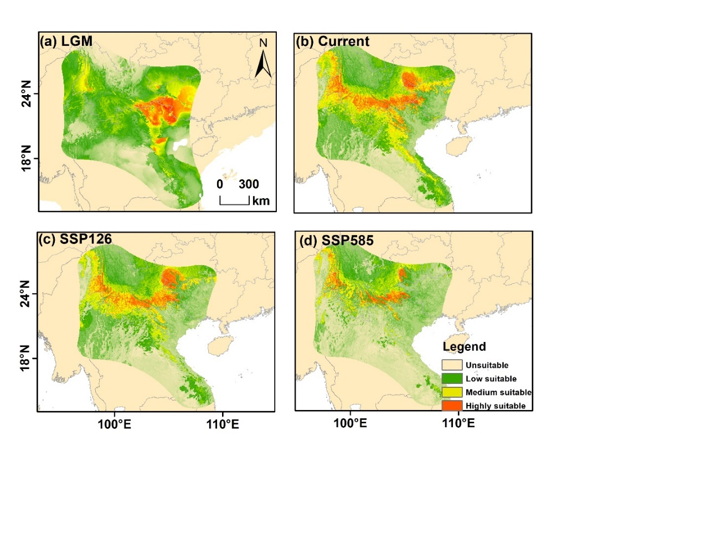

**Fig. A36** Predicted distribution ranges of *C. tonkinensis* from past to future. The color gradient from green to red represents low to high suitability. (a) represent LGM, Last Glacial Maximum, (b) current period, (c) SSP126 (2090), and SSP5858 (2090).

***Pterocarya* genus**

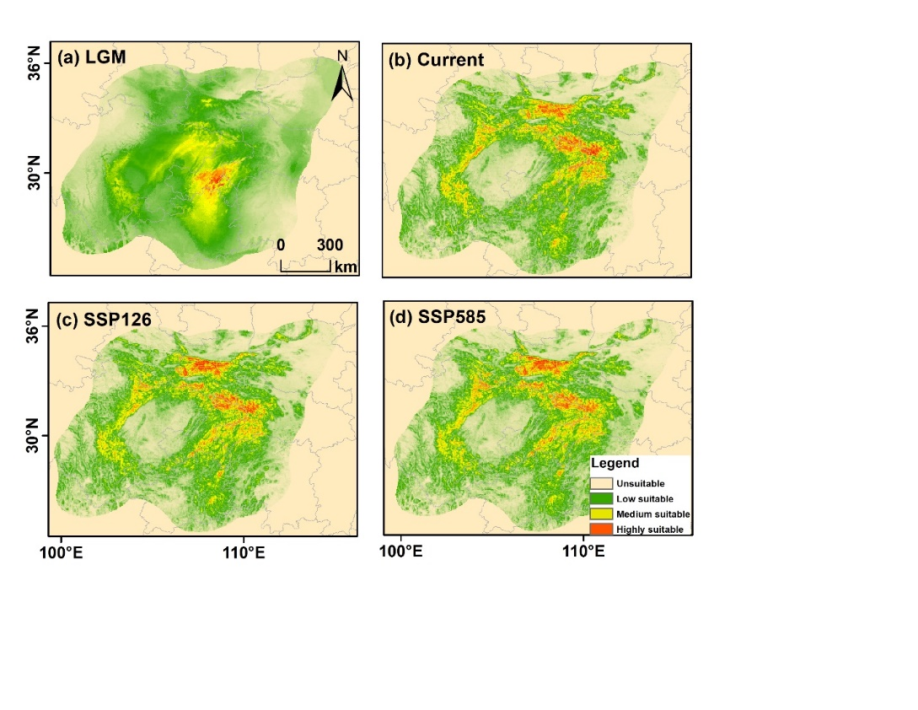

**Fig. A37** Predicted distribution ranges of *P. hupehensis* from past to future. The color gradient from green to red represents low to high suitability. (a) represent LGM, Last Glacial Maximum, (b) current period, (c) SSP126 (2090), and SSP5858 (2090).

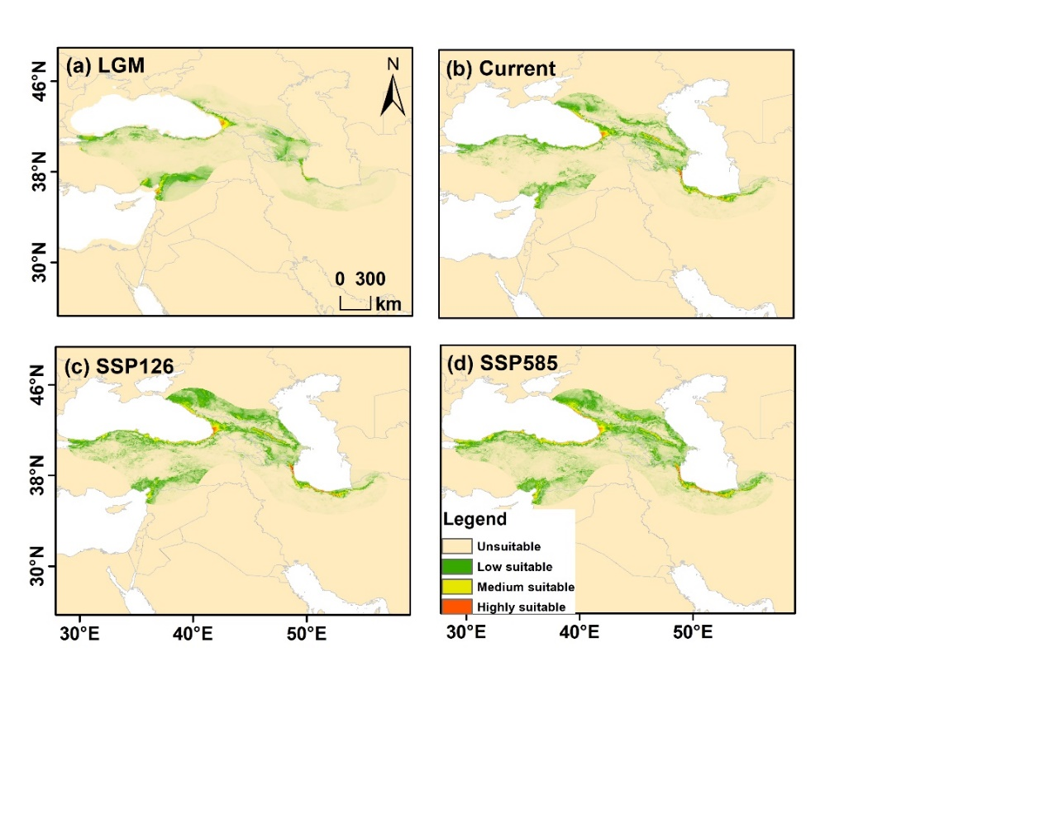

**Fig. A38** Predicted distribution ranges of *P. fraxinifolia* from past to future. The color gradient from green to red represents low to high suitability. (a) represent LGM, Last Glacial Maximum, (b) current period, (c) SSP126 (2090), and SSP5858 (2090).

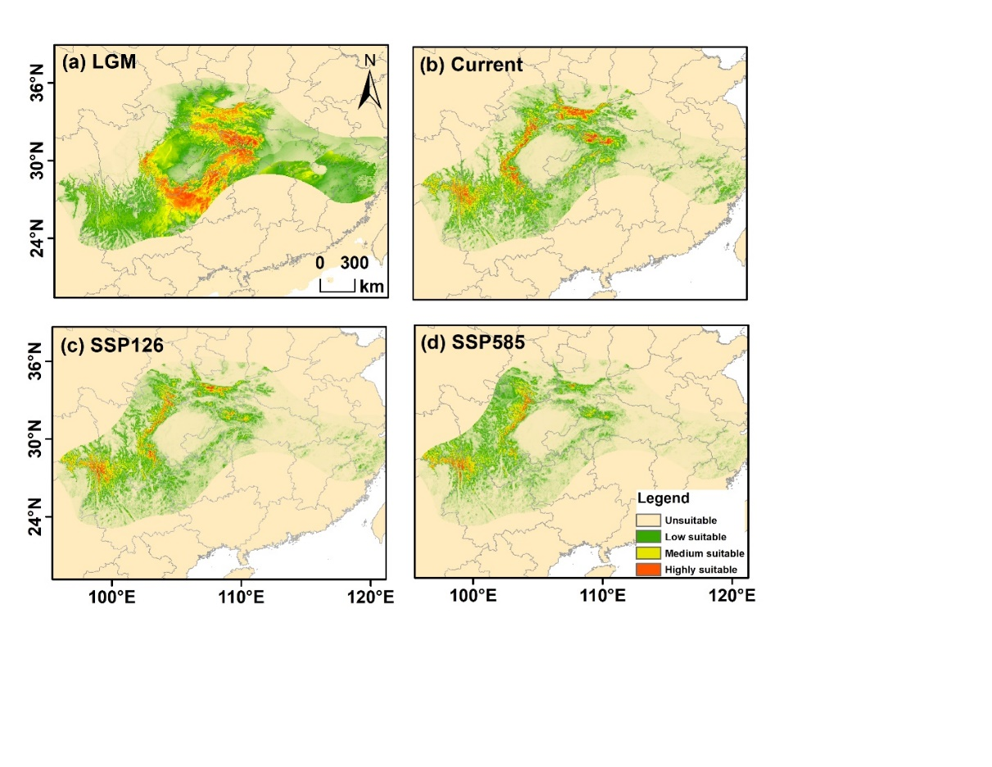

**Fig. A39** Predicted distribution ranges of *P. macroptera* from past to future. The color gradient from green to red represents low to high suitability. (a) represent LGM, Last Glacial Maximum, (b) current period, (c) SSP126 (2090), and SSP5858 (2090).

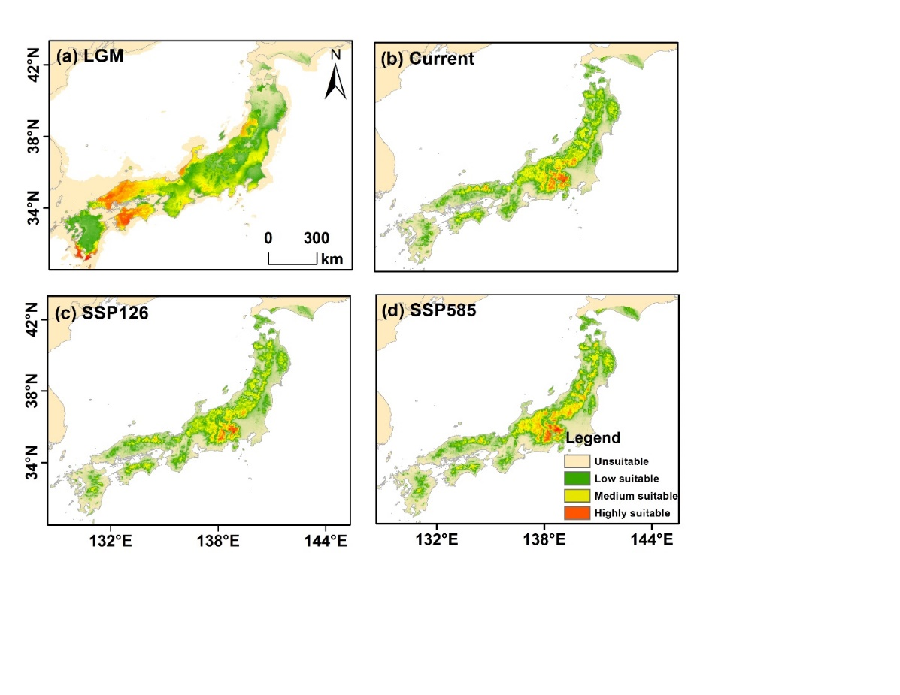

**Fig. A40** Predicted distribution ranges of *P. rhoifolia* from past to future. The color gradient from green to red represents low to high suitability. (a) represent LGM, Last Glacial Maximum, (b) current period, (c) SSP126 (2090), and SSP5858 (2090).

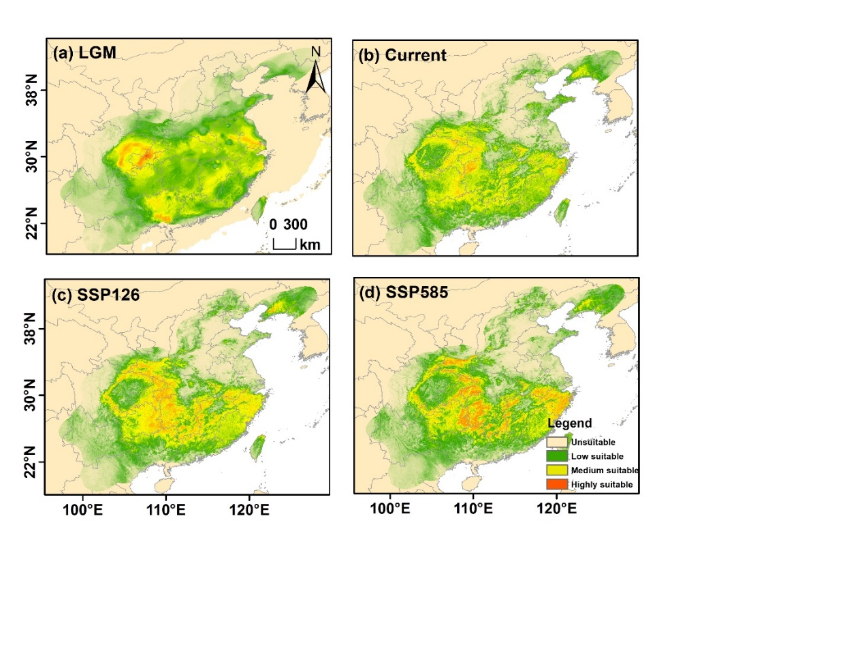

**Fig. A41** Predicted distribution ranges of *P. stenoptera* from past to future. The color gradient from green to red represents low to high suitability. (a) represent LGM, Last Glacial Maximum, (b) current period, (c) SSP126 (2090), and SSP5858 (2090).

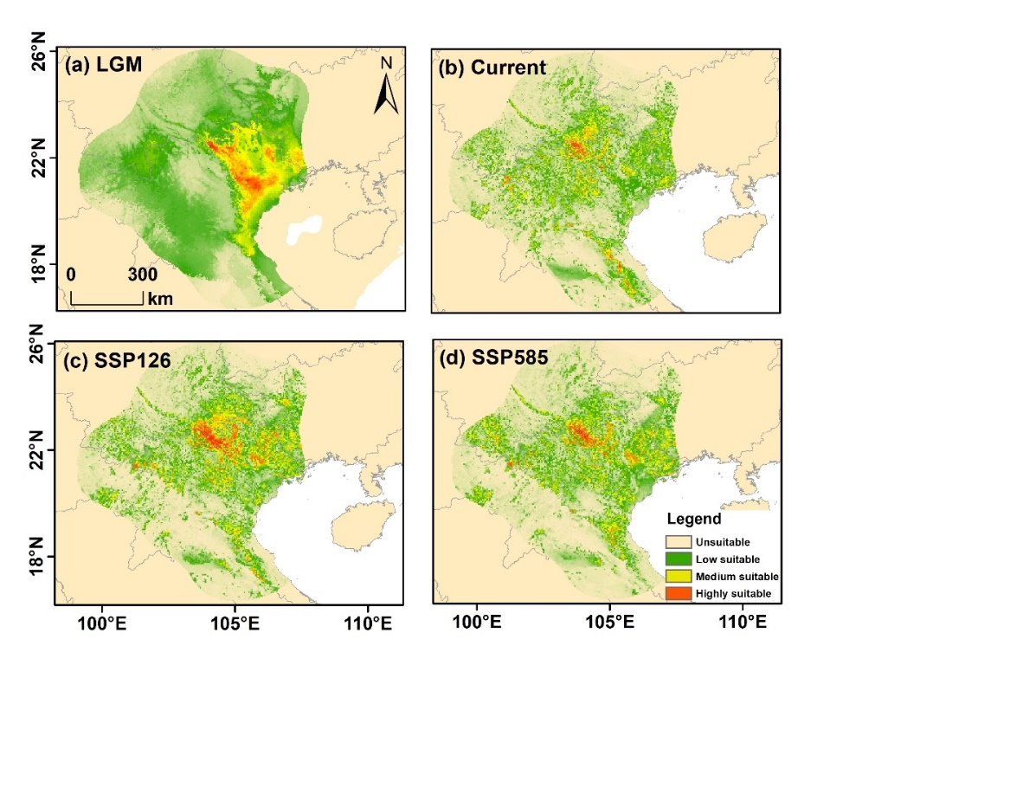

**Fig. A42** Predicted distribution ranges of *P. tonkinensis* from past to future. The color gradient from green to red represents low to high suitability. (a) represent LGM, Last Glacial Maximum, (b) current period, (c) SSP126 (2090), and SSP5858 (2090).

***Platycarya* genus**

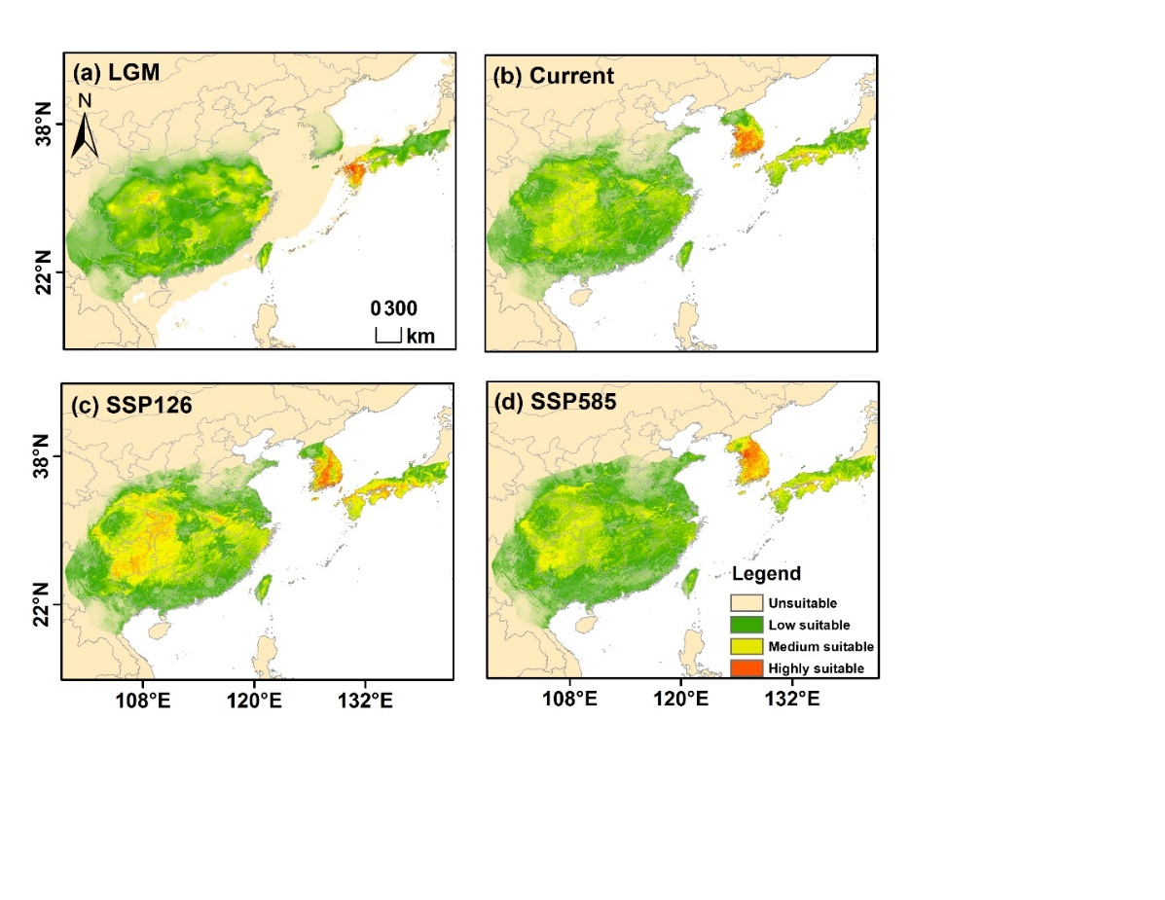

**Fig. A43** Predicted distribution ranges of *P. srobilacea* from past to future. The color gradient from green to red represents low to high suitability. (a) represent LGM, Last Glacial Maximum, (b) current period, (c) SSP126 (2090), and SSP5858 (2090).

***Cyclocarya* genus**

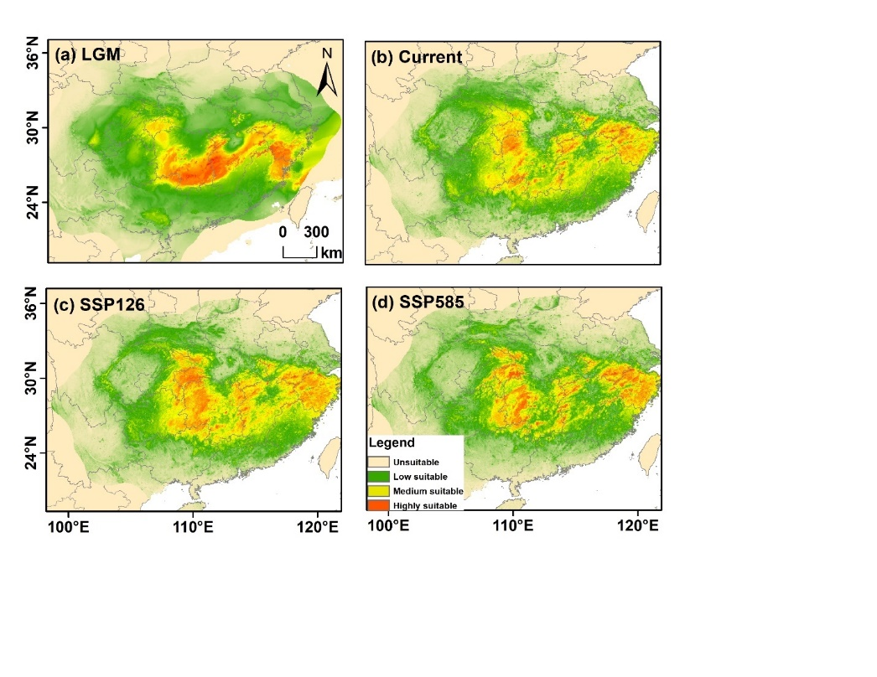

**Fig. A44** Predicted distribution ranges of *C. paliurus* from past to future. The color gradient from green to red represents low to high suitability. (a) represent LGM, Last Glacial Maximum, (b) current period, (c) SSP126 (2090), and SSP5858 (2090).

***Engelhardia* genus**

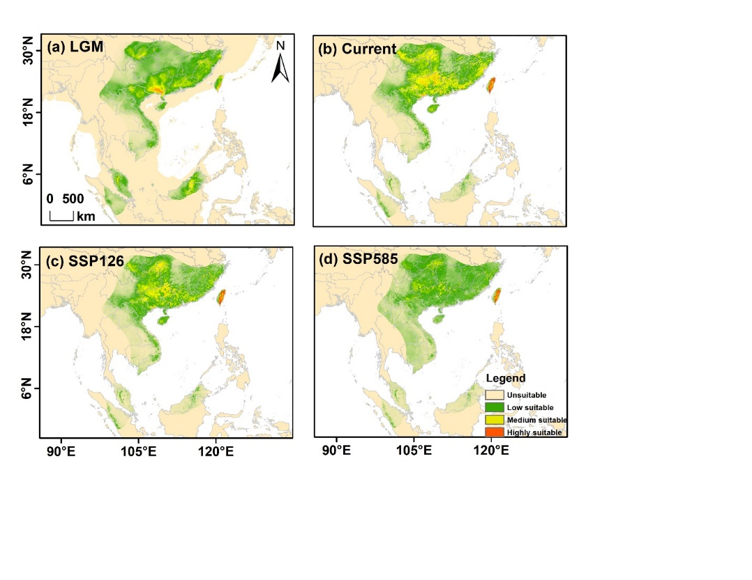

**Fig. A45** Predicted distribution ranges of *E. roxburghiana* from past to future. The color gradient from green to red represents low to high suitability. (a) represent LGM, Last Glacial Maximum, (b) current period, (c) SSP126 (2090), and SSP5858 (2090).

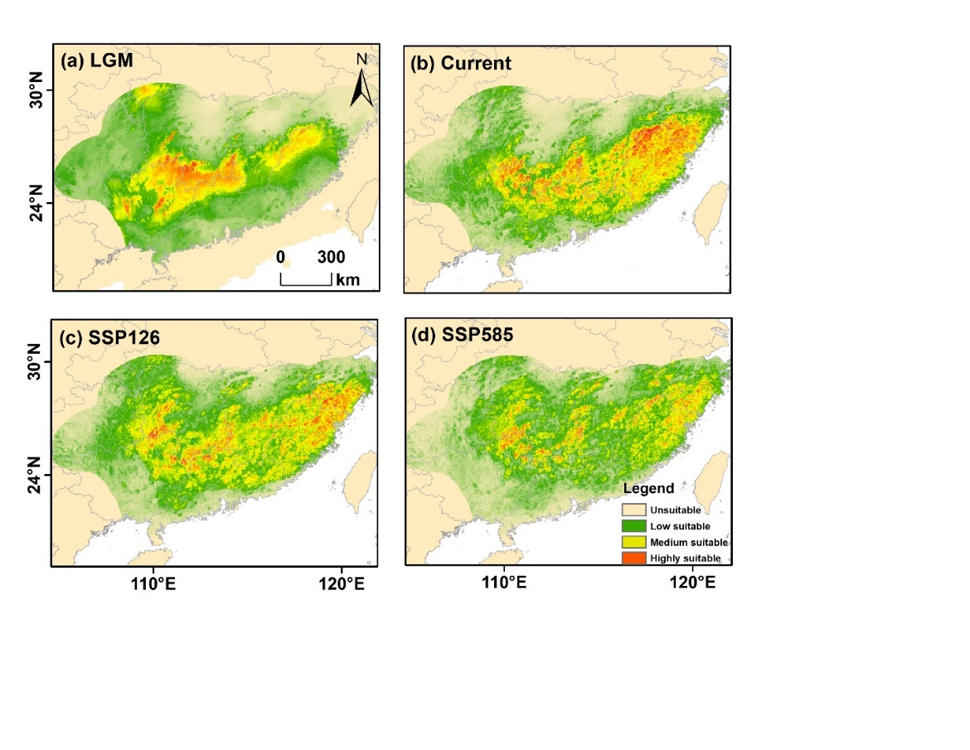

**Fig. A46** Predicted distribution ranges of *E. fenzelii* from past to future. The color gradient from green to red represents low to high suitability. (a) represent LGM, Last Glacial Maximum, (b) current period, (c) SSP126 (2090), and SSP5858 (2090).

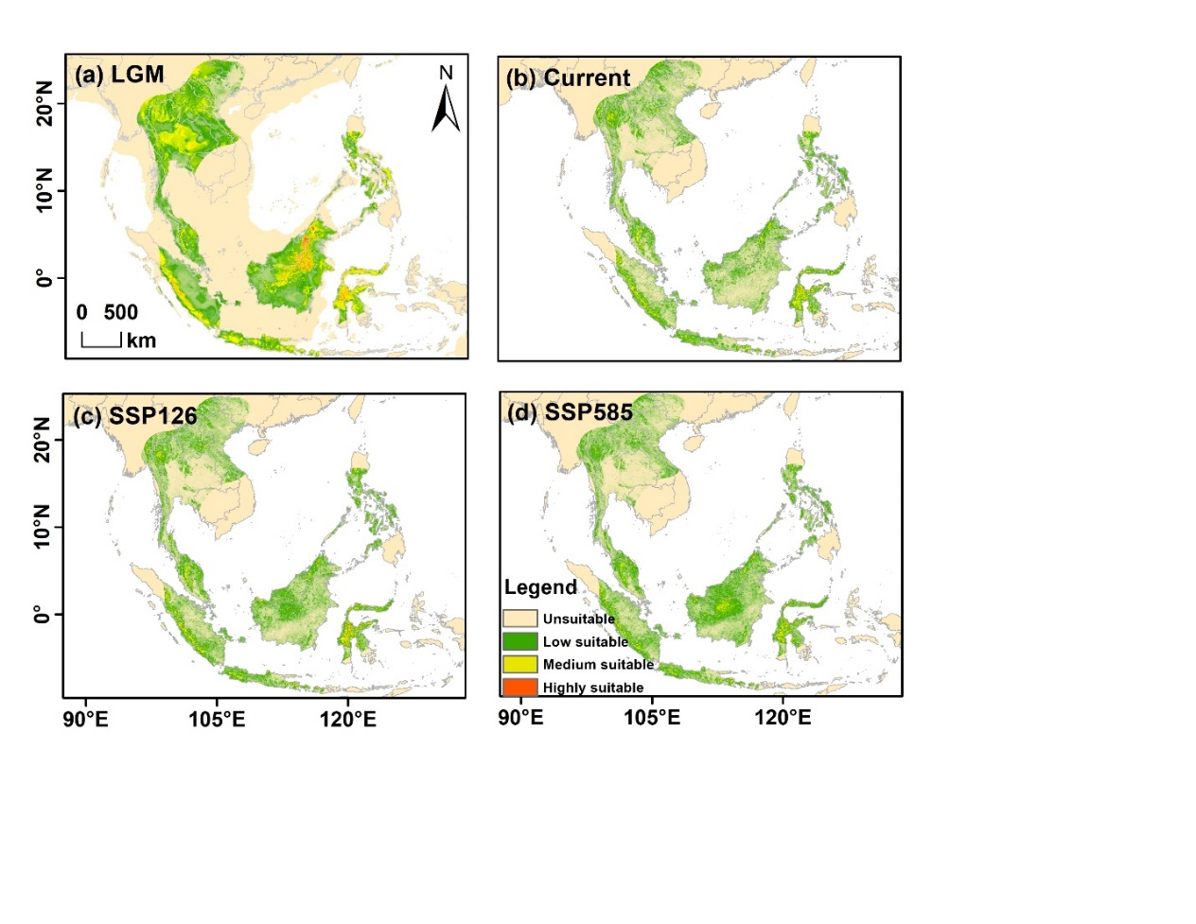

**Fig. A47** Predicted distribution ranges of *E. serrata* from past to future. The color gradient from green to red represents low to high suitability. (a) represent LGM, Last Glacial Maximum, (b) current period, (c) SSP126 (2090), and SSP5858 (2090).

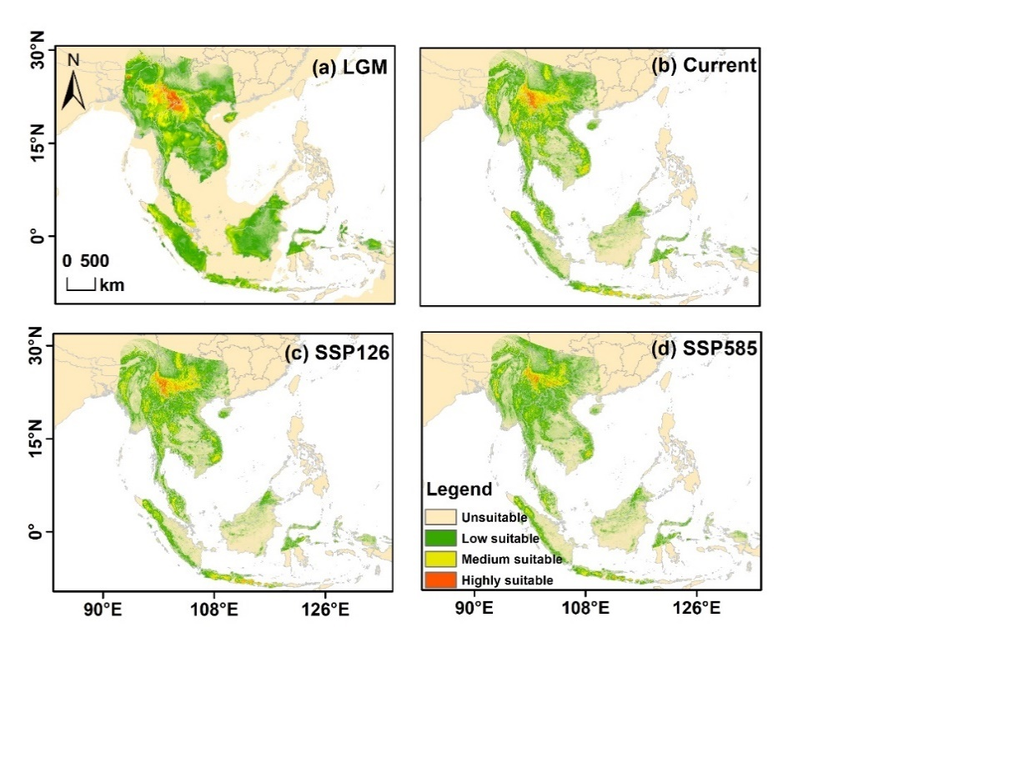

**Fig. A48** Predicted distribution ranges of *E. spicata var. spicata* from past to future. The color gradient from green to red represents low to high suitability. (a) represent LGM, Last Glacial Maximum, (b) current period, (c) SSP126 (2090), and SSP5858 (2090).

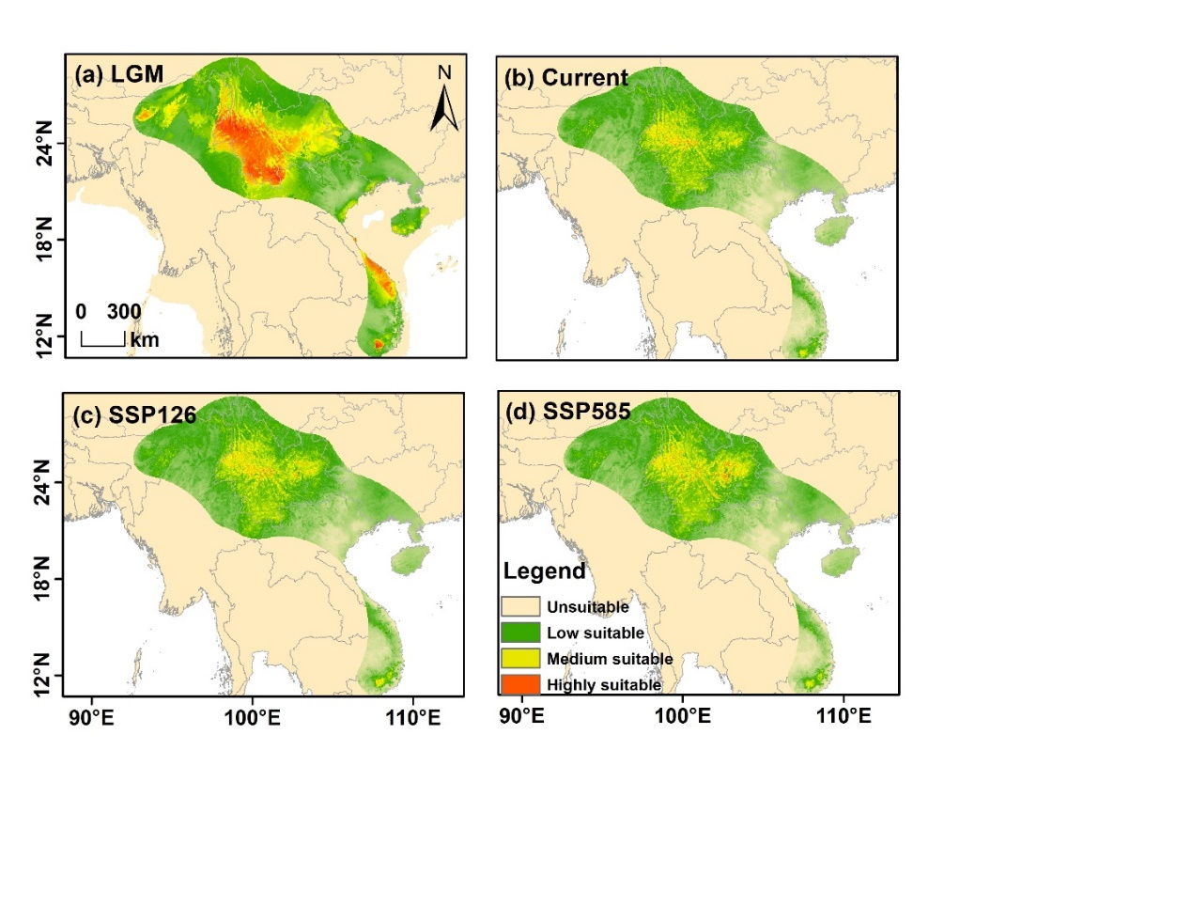

**Fig. A49** Predicted distribution ranges of *E. spicata var. aceriflora* from past to future. The color gradient from green to red represents low to high suitability. (a) represent LGM, Last Glacial Maximum, (b) current period, (c) SSP126 (2090), and SSP5858 (2090).

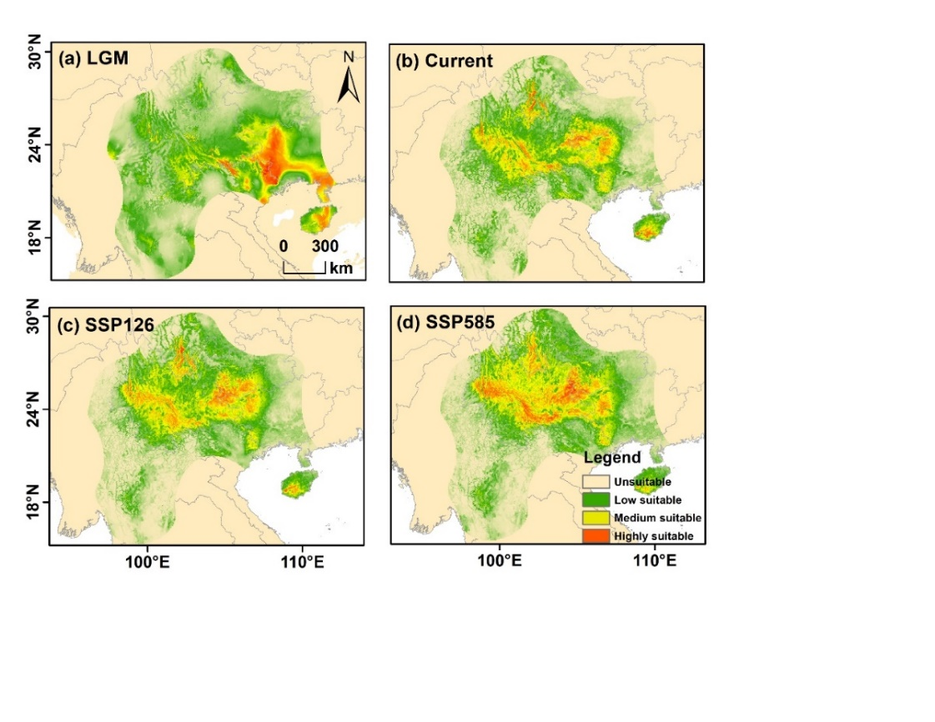

**Fig. A50** Predicted distribution ranges of *E. spicata var. colebrookeana* from past to future. The color gradient from green to red represents low to high suitability. (a) represent LGM, Last Glacial Maximum, (b) current period, (c) SSP126 (2090), and SSP5858 (2090).

***Alfaroa* genus**

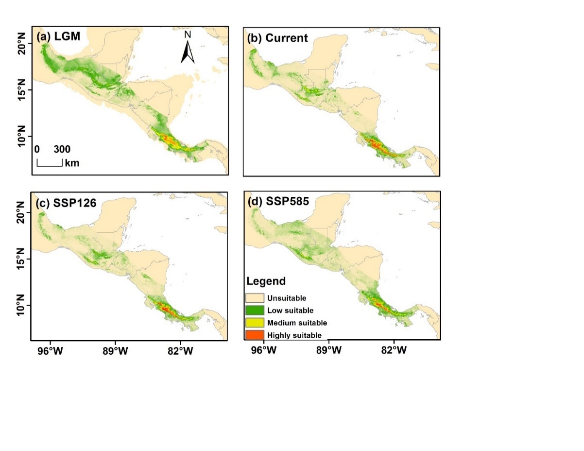

**Fig. A51** Predicted distribution ranges of *A. costaricensis* from past to future. The color gradient from green to red represents low to high suitability. (a) represent LGM, Last Glacial Maximum, (b) current period, (c) SSP126 (2090), and SSP5858 (2090).

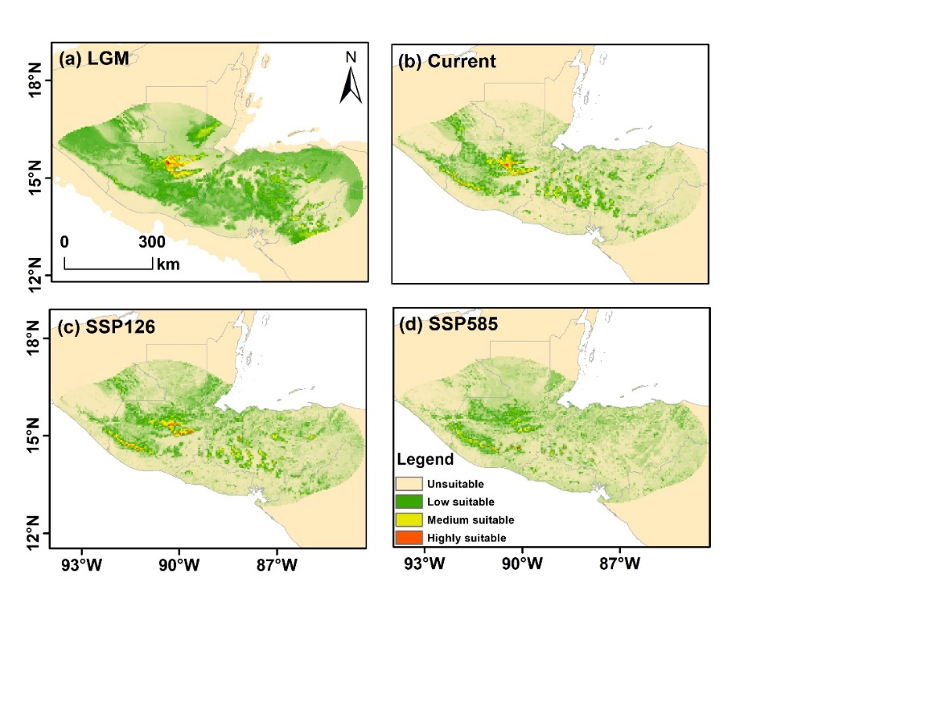

**Fig. A52** Predicted distribution ranges of *A. guatemalensis* from past to future. The color gradient from green to red represents low to high suitability. (a) represent LGM, Last Glacial Maximum, (b) current period, (c) SSP126 (2090), and SSP5858 (2090).

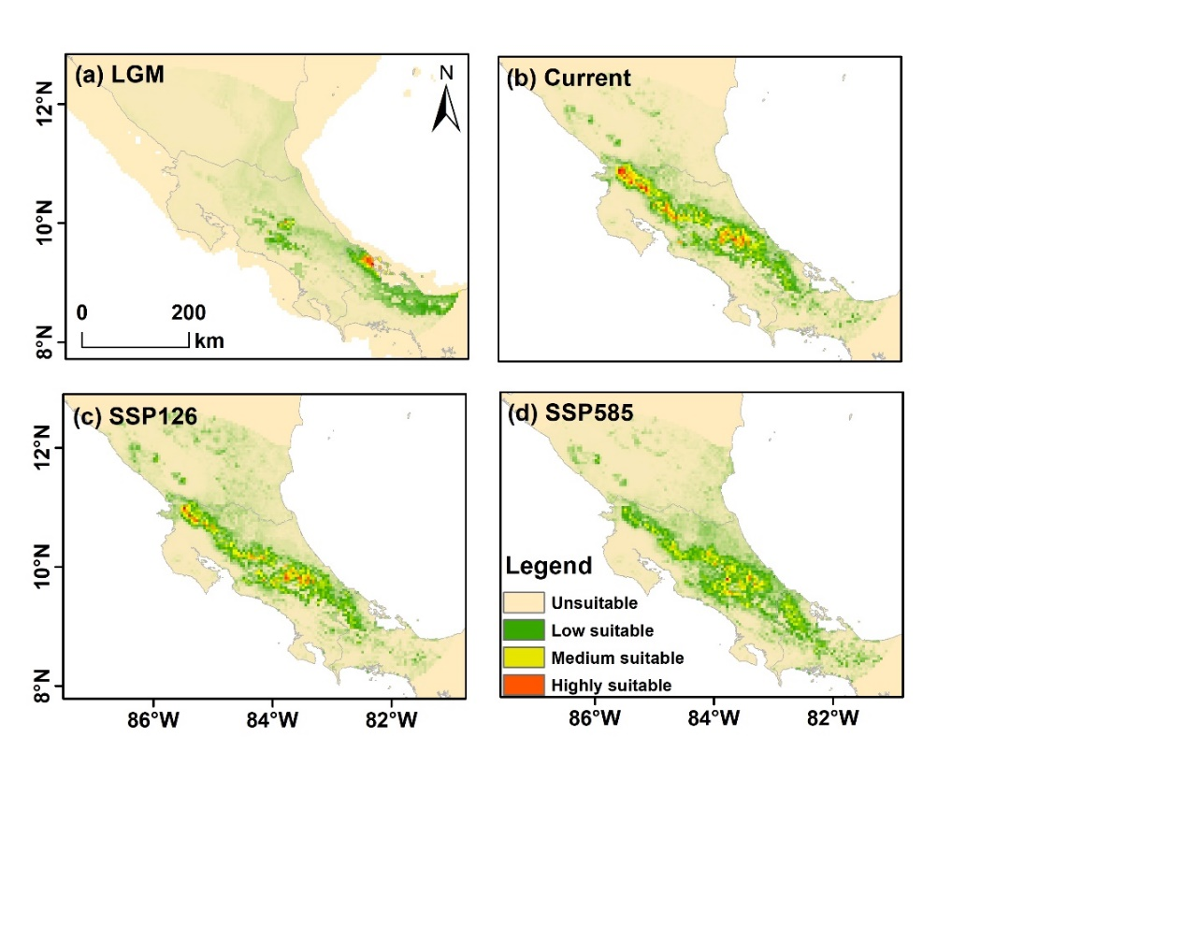

**Fig. A53** Predicted distribution ranges of *A. manningii* from past to future. The color gradient from green to red represents low to high suitability. (a) represent LGM, Last Glacial Maximum, (b) current period, (c) SSP126 (2090), and SSP5858 (2090).

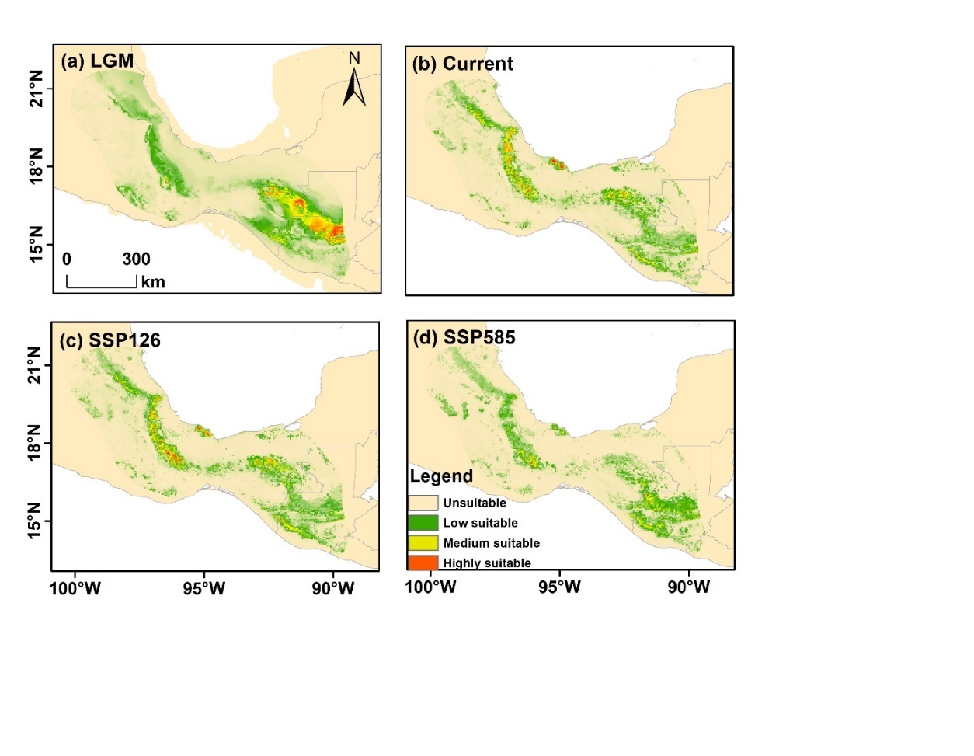

**Fig. A54** Predicted distribution ranges of *A. mexicana* from past to future. The color gradient from green to red represents low to high suitability. (a) represent LGM, Last Glacial Maximum, (b) current period, (c) SSP126 (2090), and SSP5858 (2090).

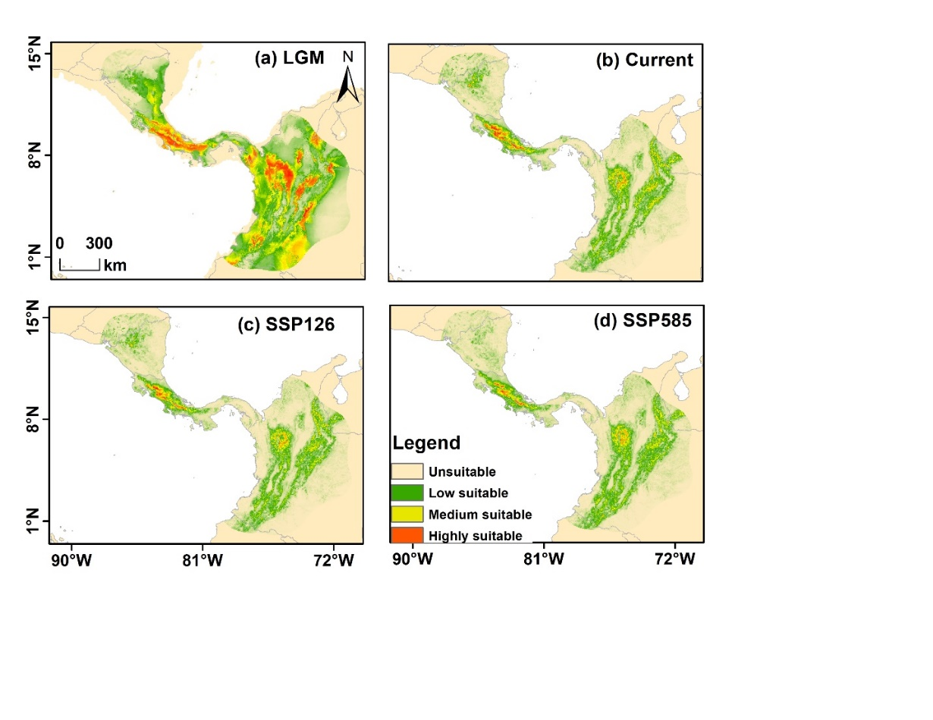

**Fig. A55** Predicted distribution ranges of *A. williamsii* from past to future. The color gradient from green to red represents low to high suitability. (a) represent LGM, Last Glacial Maximum, (b) current period, (c) SSP126 (2090), and SSP5858 (2090).

***Oreomunnea* genus**

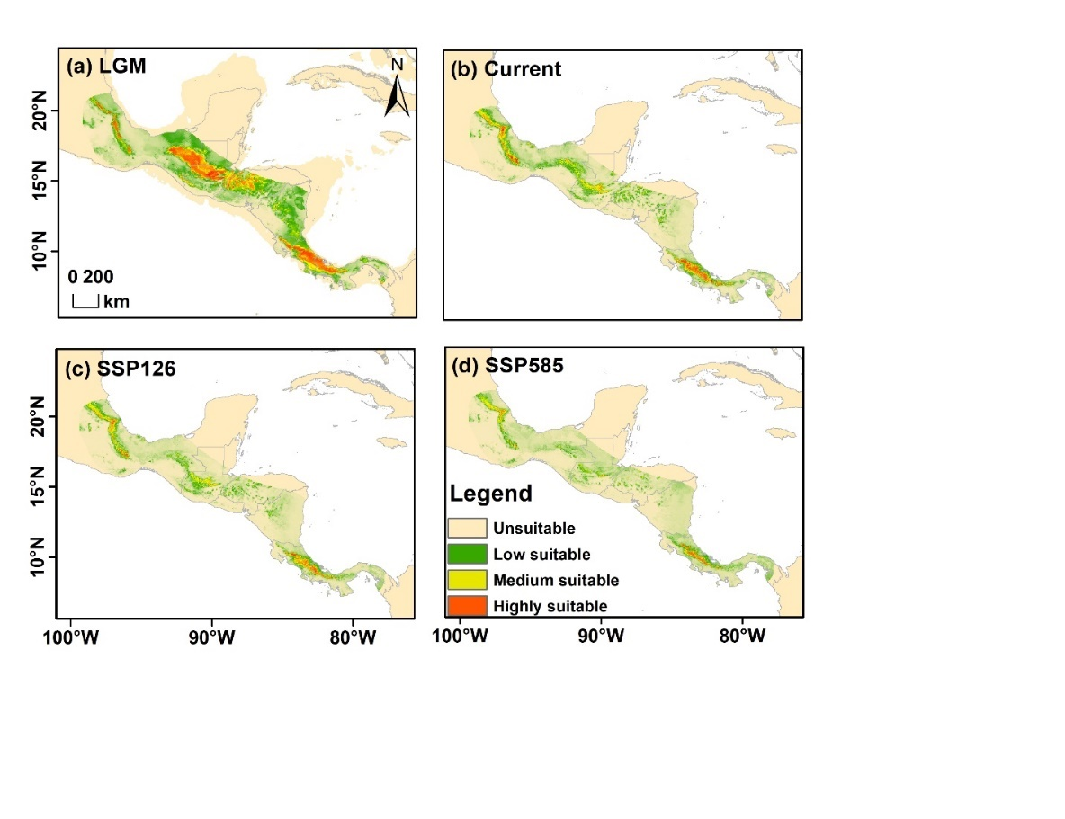

**Fig. A56** Predicted distribution ranges of *O. Mexicana* from past to future. The color gradient from green to red represents low to high suitability. (a) represent LGM, Last Glacial Maximum, (b) current period, (c) SSP126 (2090), and SSP5858 (2090).

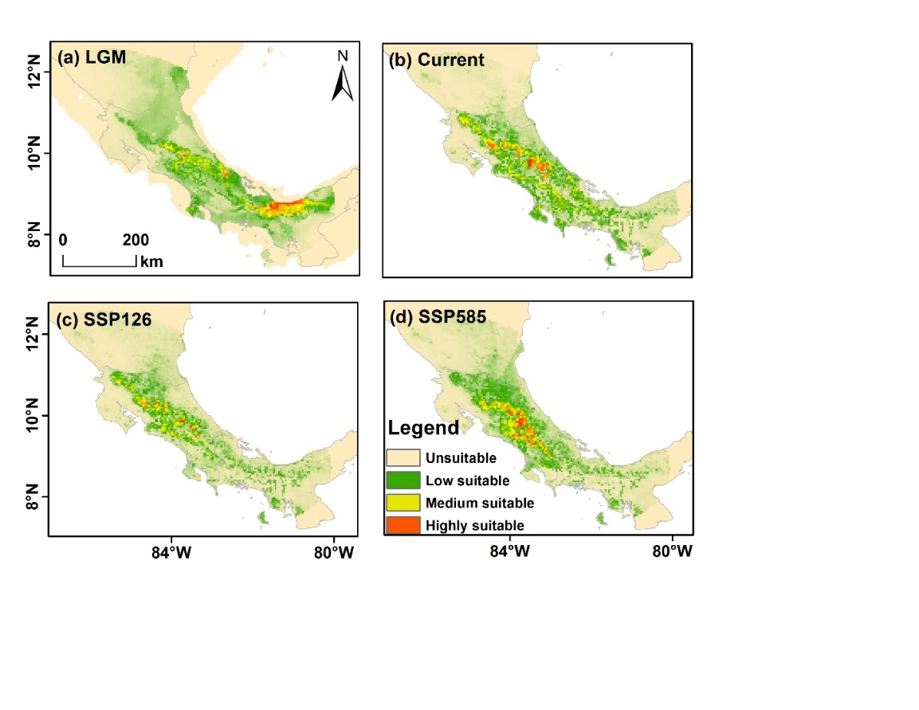

**Fig. A57** Predicted distribution ranges of *O. pterocarpa* from past to future. The color gradient from green to red represents low to high suitability. (a) represent LGM, Last Glacial Maximum, (b) current period, (c) SSP126 (2090), and SSP5858 (2090).

***Rhoiptelea* genus**

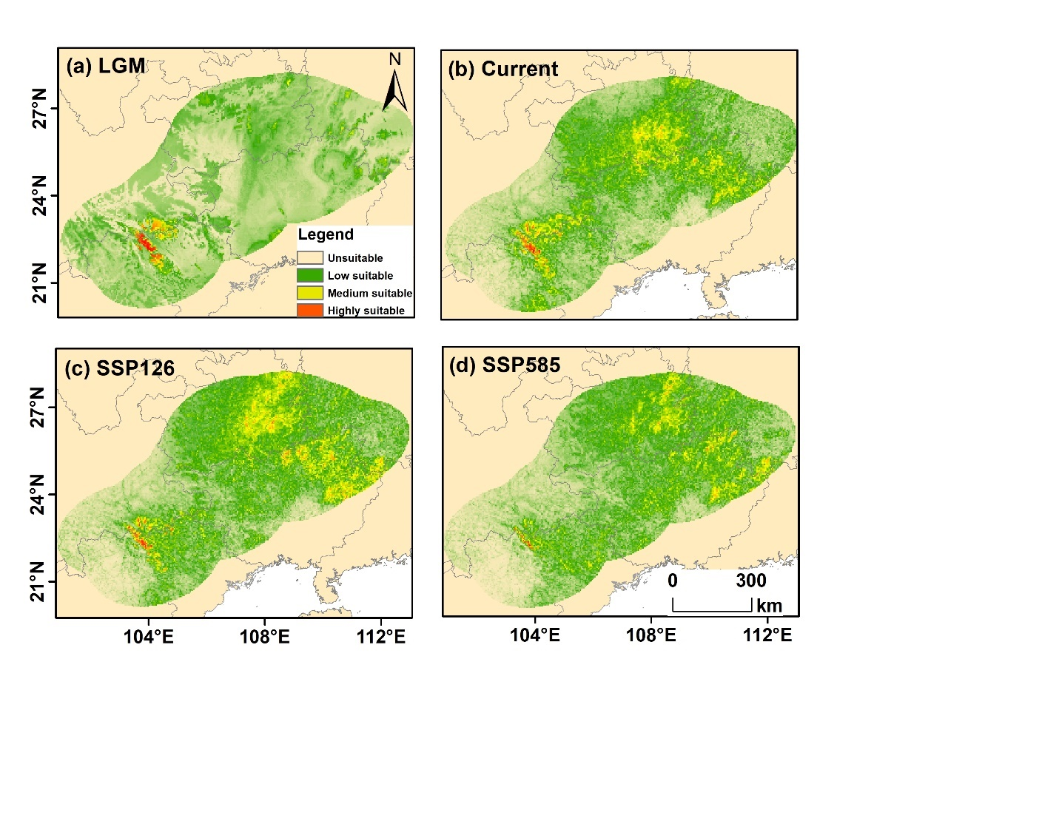

**Fig. A58** Predicted distribution ranges of *R. chiliantha* from past to future. The color gradient from green to red represents low to high suitability. (a) represent LGM, Last Glacial Maximum, (b) current period, (c) SSP126 (2090), and SSP5858 (2090).